**ABSTRACT**

TurfMaster is a comprehensive turf management system designed to streamline turf bookings, tournament registrations, coach enlistments, and sports equipment rentals. Developed using React, Next.js, TypeScript, and Node.js, the platform offers a user-friendly interface with advanced search filters and SEO-optimized URLs to enhance visibility and accessibility. TurfMaster efficiently manages bookings by allowing users to search for available turfs based on location, date, and availability, while also supporting tournament management with team registrations, scheduling, and result tracking. The system enables coach registration for training sessions and provides a seamless process for renting sports equipment. Administrators can monitor and manage bookings, inventory, and customer inquiries in real-time, ensuring efficient resource allocation and timely service delivery. By digitizing and automating core processes, TurfMaster minimizes manual effort, reduces paperwork, and enhances overall productivity, improving service quality for businesses in the sports and recreation industry.

The **TurfMaster: Turf Management System** is a comprehensive solution designed to efficiently manage turf bookings, tournament registrations, coach enlistments, and sports equipment rentals. Developed using **React**, **Next.js**, **TypeScript**, and **Node.js**, the system offers a user-friendly interface with advanced features such as search filters and SEO-optimized URLs to enhance accessibility. TurfMaster is ideal for sports facilities, recreation centers, and turf owners seeking to streamline their operations. The system effectively manages bookings by allowing users to search for available turfs based on location, date, and availability, ensuring improved resource allocation. It also facilitates seamless tournament registration and scheduling, along with coach booking for training sessions. The integrated equipment rental service simplifies the process of tracking and managing rental items. By automating core processes, TurfMaster reduces manual effort, minimizes paperwork, and enhances productivity. The system ensures real-time updates on bookings, inventory, and customer inquiries, enabling administrators to monitor and manage their services efficiently. This solution not only optimizes turf management but also improves customer satisfaction by ensuring timely service delivery and accurate record-keeping.

**2. SYSTEM ANALYSIS AND STUDY**

**2.1 EXISTING SYSTEM**

The current turf management process is largely manual, resulting in inefficiencies and delays. Turf bookings, tournament registrations, and equipment rental requests are often handled through phone calls, emails, or in-person inquiries, leading to frequent miscommunication and scheduling conflicts. Managing customer inquiries, tracking turf availability, and maintaining records for coaches and equipment rentals becomes cumbersome without a dedicated system. Additionally, there’s no centralized platform to manage customer feedback, loyalty programs, or ensure secure online payments.

**Disadvantages of Existing System:**

* Tracking real-time turf availability is difficult and prone to errors.
* Scheduling and conflict management require constant manual intervention, increasing the risk of double bookings.
* There is no streamlined process for tournament creation, team registration, or coach management.
* Equipment rental records are often misplaced or outdated, resulting in inventory mismanagement.
* Managing customer memberships, loyalty programs, and feedback is tedious without automation.
* The absence of a modern UI makes it difficult for users to navigate the booking process.
* The existing system lacks SEO-optimized URLs and smooth navigation, limiting its reach and usability.

**2.2 PROPOSED SYSTEM**

The proposed **TurfMaster** system introduces a fully automated, web-based platform designed to streamline turf bookings, tournament management, coach registrations, and equipment rentals. Using modern technologies like **React**, **Next.js**, **TypeScript**, and **Node.js**, the system ensures efficient resource management and improved customer experience. Users can track real-time turf availability, schedule tournaments, and rent sports equipment with ease. Separate login portals for customers and turf owners provide role-based access, ensuring better data security and control.

**Advantages of Proposed System:**

* Ensures real-time tracking of turf availability, reducing scheduling conflicts.
* Provides an automated process for tournament creation, team registration, and coach management.
* Streamlines equipment rental with proper inventory tracking.
* Facilitates secure online payments and automated billing for convenience.
* Offers loyalty programs and membership plans to retain customers.
* Integrated customer review and feedback system to improve service quality.
* The modern UI with interactive features enhances the user experience.
* SEO-friendly URL routing improves search engine visibility and accessibility.
* Reduces manual paperwork, minimizes errors, and improves overall productivity.

**2.3 SYSTEM STUDY**

**FEASIBILITY STUDY**

In this phase, the feasibility of the **TurfMaster** project is analyzed. For this purpose, understanding the key system requirements is essential. The feasibility analysis is categorized into three main areas: **Economic Feasibility**, **Technical Feasibility**, and **Operational Feasibility**.

**ECONOMIC FEASIBILITY**

The **TurfMaster** system is designed to provide cost-effective solutions for turf management, ensuring that the benefits outweigh the implementation costs. By automating manual processes like turf bookings, tournament registrations, and equipment rentals, the system significantly reduces administrative workload, minimizing the need for additional manpower. With improved operational efficiency, businesses can achieve faster service delivery, resulting in increased customer satisfaction and revenue growth. The cost of developing and deploying the system is reasonable compared to the long-term gains it offers. Enhanced customer engagement through features like loyalty programs, feedback systems, and improved UI ensures consistent business growth, making **TurfMaster** economically feasible.

**TECHNICAL FEASIBILITY**

The **TurfMaster** system is built using modern technologies such as **React**, **Next.js**, **TypeScript**, and **Node.js**, ensuring optimal performance, scalability, and security. These technologies provide a powerful and flexible development environment that easily integrates with database systems for efficient data management. Since the system will operate on web-based platforms, it requires minimal hardware upgrades and can be deployed seamlessly on cloud services like **Vercel**, **AWS**, or **DigitalOcean**. Additionally, the tools and frameworks used are well-documented and widely supported, ensuring long-term sustainability and simplified maintenance. The technical requirements for this project align with industry standards, making the system technically feasible.

**OPERATIONAL FEASIBILITY**

The **TurfMaster** system is designed to meet the functional and operational needs of both customers and turf owners. Its intuitive interface ensures users can effortlessly search for turfs, register for tournaments, book coaches, and rent equipment without extensive training. The automated scheduling, real-time booking updates, and secure payment integration simplify complex processes and reduce manual errors. Turf owners can easily manage bookings, track equipment inventory, and oversee customer inquiries from a centralized dashboard. With the management team’s full support and modern technology facilitating efficient communication, the system is expected to function smoothly with minimal disruptions. As a result, the **TurfMaster** system is operationally feasible and capable of delivering enhanced productivity and improved customer satisfaction.

**3.1 MODULES DESCRIPTION**

A module is a collection of functionalities designed to perform specific tasks within the system. Each module in the **TurfMaster** system focuses on distinct aspects of turf management, ensuring seamless integration and efficient operation. There are six key modules in this project:

1. **User Management Module**
2. **Turf Booking and Scheduling Module**
3. **Tournament Management Module**
4. **Coach Registration and Management Module**
5. **Equipment Rental Module**
6. **Payment and Billing Module**

**1) USER MANAGEMENT MODULE**

The **User Management Module** is responsible for handling user-related functions such as registration, login, and profile management. It supports role-based access, ensuring separate portals for **Customers** and **Turf Owners**. Customers can book turfs, join tournaments, and rent equipment, while Turf Owners can manage turf availability, schedules, and customer inquiries. This module also incorporates features like membership plans, loyalty programs, and customer feedback systems to improve user engagement.

**2) TURF BOOKING AND SCHEDULING MODULE**

The **Turf Booking and Scheduling Module** is designed to manage real-time turf availability and automate scheduling processes. Users can search for available turfs using advanced filters such as location, date, and time slot. The system prevents double bookings through automated conflict management, ensuring seamless scheduling. Turf Owners can also define time slots, pricing, and booking rules within this module.

**3) TOURNAMENT MANAGEMENT MODULE**

The **Tournament Management Module** facilitates the creation and management of sports tournaments. It enables Turf Owners to set up tournament details, manage team registrations, and schedule match fixtures. The system allows participants to register, track tournament progress, and view results online. This module ensures efficient coordination of tournaments while minimizing scheduling conflicts.

**4) COACH REGISTRATION AND MANAGEMENT MODULE**

The **Coach Registration and Management Module** streamlines the process of hiring and booking coaches for training sessions. Turf Owners can list certified coaches along with their expertise, availability, and pricing. Customers can browse available coaches, check reviews, and book them directly through the platform. This module simplifies communication between coaches and clients, enhancing the overall training experience.

**5) EQUIPMENT RENTAL MODULE**

The **Equipment Rental Module** is designed to manage sports equipment rentals efficiently. Users can browse available equipment, check pricing, and place rental requests directly through the platform. Turf Owners can update inventory, track rented items, and monitor return deadlines. This module ensures proper record-keeping, reducing the chances of misplaced or lost equipment.

**6) PAYMENT AND BILLING MODULE**

The **Payment and Billing Module** manages secure online transactions for turf bookings, tournament registrations, coach bookings, and equipment rentals. Integrated with reliable payment gateways, this module ensures fast and secure payment processing. It also generates automated invoices, tracks pending payments, and maintains financial records to ensure smooth cash flow management.

This module improves financial transparency, reduces manual calculation errors, and enhances overall system efficiency.

**4. SYSTEM SPECIFICATION**

* **4.1 HARDWARE REQUIREMENT**
* **CPU Type:** Intel Core i3 / i5 / i7 or higher
* **Clock Speed:** 2.0 GHz or above
* **RAM:** 8 GB or higher (Recommended for optimal performance)
* **Keyboard:** Standard or Multimedia Keyboard
* **Mouse:** Optical Mouse / Touchpad
* **Hard Disk:** 256 GB SSD or 500 GB HDD (Minimum Requirement)
* **4.2 SOFTWARE REQUIREMENT**
* **Development Technologies:** **React.js**, **Next.js**, **TypeScript**, **Node.js**
* **Database:** **MongoDB** / **PostgreSQL** (Recommended for flexibility and scalability)
* **Web Server:** **Localhost** using tools like **XAMPP**, **Vercel**, or **Node.js** server
* **Hosting Platform:** **Netlify** (For frontend hosting)
* **Operating System:** **Windows 10 / 11**, **Linux**, or **MacOS** (Any modern OS compatible with the development stack)

**4.3 ABOUT THE SOFTWARE**

**Website Design and Development**

Website design involves planning, creating, and updating web pages to ensure optimal user experience, navigation, and functionality. The design of the **TurfMaster** system integrates modern web design principles to deliver an interactive, efficient, and visually appealing platform for turf booking, tournament management, and equipment rental.

The **TurfMaster** system is developed using advanced web technologies like **Next.js**, **React.js**, and **TypeScript** for the frontend, ensuring seamless navigation, efficient rendering, and optimized SEO performance. For the backend, **Node.js** is utilized to manage server-side operations and ensure smooth data communication with the database.

In modern web development, elements like responsive UI design, search filters, and secure payment gateways are vital. The **TurfMaster** website integrates all these elements to improve user experience, enhance performance, and achieve project objectives efficiently.

**Understanding a Web Application**

Web applications serve multiple purposes, such as providing information, selling services, and facilitating user interactions. The **TurfMaster** system is designed to provide real-time booking, tournament organization, and rental services with an engaging and intuitive interface.

Each webpage is structured using **Next.js** dynamic routing, ensuring separate URLs for improved SEO visibility. The user interface is developed using **React.js** components, ensuring consistency, modularity, and reusability throughout the platform.

The system includes various modules such as **User Registration**, **Turf Booking**, **Tournament Management**, and **Equipment Rental**, each designed to meet the specific needs of customers and turf owners.

**Deciding a Web Interface**

The **TurfMaster** interface is designed using modern web technologies to ensure:  
**>>** Smooth navigation and fast page loading  
**>>**  Attractive design with engaging buttons, animations, and effects  
**>>** Interactive forms for registration, bookings, and feedback  
**>>** Advanced search filters to simplify turf selection  
**>>** Mobile responsiveness for seamless use on different devices

The intuitive layout ensures that both casual users and registered members can easily access features like booking details, tournament schedules, and equipment rental options.

**Templates and Components**

In **Next.js**, reusable components are created for consistency across the website. Key UI elements such as headers, footers, booking cards, and filter options are designed as dynamic components for better scalability and improved performance.

Dynamic templates are utilized to display content efficiently across various pages, ensuring uniform branding and design consistency.

**Web Page Design**

Each page in the **TurfMaster** system is designed with a clear goal in mind:

* The **Homepage** highlights key services, promotions, and offers.
* The **Booking Page** provides real-time turf availability with an intuitive booking process.
* The **Tournament Module** simplifies team registration and match scheduling.
* The **Equipment Rental Section** offers a seamless catalog browsing experience.
* The **About Us** and **Contact Us** pages ensure informative and user-engaging content.

Each webpage is carefully structured with visual hierarchy, navigation logic, and interactive elements to enhance usability and improve customer engagement.

By combining the power of **Next.js**, **React.js**, and **Node.js**, the **TurfMaster** system delivers a powerful, user-centric platform that meets modern web standards and ensures a smooth, reliable experience for both customers and turf owners.

**Introduction to JavaScript**

JavaScript is a versatile and essential programming language used to create dynamic content on web pages. It was initially developed by Netscape as a means to add dynamic and interactive elements to websites. Today, JavaScript is widely supported and forms a core part of web development alongside HTML and CSS.

• JavaScript is a client-side scripting language that allows web developers to create interactive and dynamic web pages. • It can update and change both HTML and CSS. • JavaScript can calculate, manipulate, and validate data within the browser itself, improving website performance. • JavaScript can run on various platforms, including web browsers, servers, and even embedded devices.

**Key Features of JavaScript**

• Lightweight and Interpreted: JavaScript is executed within the user’s browser, reducing the load on the server. • Object-Based Language: JavaScript uses objects to manage data and manipulate elements within a web page. • Platform Independent: JavaScript can run on various operating systems and browsers without modifications. • Event-Driven Programming: JavaScript responds to user actions like clicks, keypresses, and mouse movements.

**Common Uses of JavaScript**

• Form Validation: JavaScript can check if data entered in a form is valid before submission. • Interactive Web Applications: JavaScript enables dynamic user interfaces, animations, and interactive content. • AJAX Support: JavaScript enables asynchronous communication with servers, enhancing page performance and user experience. • DOM Manipulation: JavaScript modifies the structure, content, and style of web pages directly in response to user actions.

**JavaScript Variables**

JavaScript uses three types of variable declarations:

• **var**: Declares a variable globally or within the function where it is declared. • **let**: Declares a block-scoped local variable. • **const**: Declares a variable that cannot be reassigned.

**Example:**

let message = "Welcome to TurfMaster!";

document.getElementById("welcome-msg").innerHTML = message;

**JavaScript Data Types**

JavaScript has six primitive data types: • **String** • **Number** • **Boolean** • **Undefined** • **Null** • **Symbol**

Additionally, JavaScript includes **Object** as a non-primitive data type.

**Introduction to CSS (Cascading Style Sheets)**

CSS is a stylesheet language used to describe the presentation of a document written in HTML. CSS is a core technology for web design and is used to control the layout and appearance of web pages.

• CSS controls the color, font, size, spacing, layout, and overall design of a website. • It separates the content from the presentation, making it easier to manage and update web pages. • CSS enhances user experience by providing responsive design features that adjust layouts for different devices.

**Key Features of CSS**

• CSS enables consistent design across multiple pages by linking them to a single stylesheet. • It supports responsive design, ensuring that web pages are accessible on various devices. • CSS3 introduces powerful features like animations, gradients, and grid layouts for enhanced web design.

**Types of CSS**

1. **Inline CSS**: Applied directly to an HTML element using the style attribute.
2. **Internal CSS**: Defined within the <style> tag in the <head> section.
3. **External CSS**: Linked as a separate .css file using the <link> tag.

Example:

body {

background-color: #f0f0f0;

font-family: Arial, sans-serif;

color: #333;

}

Introduction to Database Management Systems (DBMS)

A Database Management System (DBMS) is essential for storing, retrieving, and managing data efficiently in web applications. Popular DBMS systems include MySQL, MongoDB, PostgreSQL, and Microsoft SQL Server.

Key Features of a DBMS

• **Data Integrity**: Ensures data accuracy and consistency through various constraints and validation rules. • **Data Security**: Controls access to data with encryption and user authentication protocols. • **Scalability**: Handles large volumes of data efficiently for dynamic web applications like TurfMaster. • **Backup and Recovery**: Ensures data is protected from system failures through automated backups.

SQL (Structured Query Language)

SQL is the standard language for interacting with relational databases. Basic SQL operations include:

• **SELECT** – Retrieves data from a database. • **INSERT** – Adds new records to a database. • **UPDATE** – Modifies existing records. • **DELETE** – Removes records from a database.

Example:

SELECT * FROM turf_data WHERE status = 'active';

Combining JavaScript, CSS, and Database systems ensures that web applications like TurfMaster are dynamic, interactive, and capable of efficiently handling large data sets for seamless user experiences.

**Introduction to Next.js**

Next.js is a powerful React framework that enables developers to build fast, scalable, and SEO-friendly web applications. It combines the best of both worlds: server-side rendering (SSR) and static site generation (SSG).

**Key Features of Next.js**

• **Server-side Rendering (SSR)**: Ensures content is generated on the server before reaching the client, improving performance and SEO.

• **Static Site Generation (SSG)**: Pre-builds pages at compile time to deliver faster load times. • **API Routes**: Next.js allows developers to build API endpoints directly within the application.

• **Automatic Code Splitting**: Ensures only necessary JavaScript is loaded on each page for optimal performance.

• **Image Optimization**: Built-in support for optimizing images for faster loading.

**Routing in Next.js**

Next.js uses a file-based routing system where the file structure determines the URL routes. Example:

/pages

/index.js // Home page

/about.js // About page

/contact.js // Contact page

To link between pages, use the Link component from Next.js:

import Link from 'next/link';

function Home() {

return (

<div>

<h1>Welcome to TurfMaster!</h1>

<Link href="/about">Learn More About Us</Link>

</div>

);

}

API Integration with Next.js

Next.js simplifies building APIs directly within the /pages/api directory. Example of an API route:

// /pages/api/hello.js

export default function handler(req, res) {

res.status(200).json({ message: "Welcome to TurfMaster API!" });

}

**Performance Optimization in Next.js**

• **Image Optimization**: The next/image component optimizes image loading by resizing and lazy loading images. • **Code Splitting**: Next.js automatically splits code to reduce bundle sizes. • **Incremental Static Regeneration (ISR)**: Allows developers to update static pages after deployment for improved scalability. • **Prefetching Links**: Next.js prefetches linked pages to enhance navigation speed.

Next.js offers the ideal framework for TurfMaster to deliver lightning-fast, SEO-friendly, and feature-rich web experiences.

**Identifying Browser & Platform in Next.js**

In Next.js, identifying the client's browser and platform is essential for optimizing the user experience. Next.js can access this information using server-side functions like getServerSideProps() or middleware. By identifying the user agent, developers can tailor content, design, or features to suit specific browsers or devices.

This is particularly useful for:

* Detecting mobile versus desktop views.
* Serving optimized resources for different platforms.
* Customizing user experiences based on browser capabilities.

**Data Transmission Using GET and POST Methods**

Next.js simplifies data transmission between the client and server using API routes. These routes handle HTTP requests like GET and POST efficiently.

* **GET Method:** Ideal for retrieving data, where parameters are passed directly in the URL. It is suitable for requests that do not require security or sensitive information. However, GET requests have size limitations and can expose data in the URL.
* **POST Method:** Suitable for submitting data securely. The POST method sends data within the HTTP body, making it better for transferring large or sensitive information. It is commonly used for form submissions, authentication, and creating records in databases.

Both GET and POST are integral in building dynamic web applications like TurfMaster.

**Functions in Next.js**

Functions are reusable blocks of code designed to perform specific tasks. In Next.js, functions enhance modularity and simplify complex logic. Functions can be:

* **Utility Functions:** Used for repetitive tasks like data formatting, string manipulation, or date conversion.
* **Custom Hooks:** Specialized functions that manage state or side effects in Next.js applications.

Adhering to proper function structure ensures clarity, improved debugging, and better code scalability in your TurfMaster project.

**Coding Standards in Next.js**

Following coding standards is crucial for maintaining clean, efficient, and readable code. Some best practices for Next.js include:

* **Consistent Naming Conventions:** Use camelCase for variables and PascalCase for React components.
* **Folder Structure:** Organize files logically by features or modules to improve scalability.
* **Linting Tools:** Tools like ESLint and Prettier ensure code consistency and reduce potential errors.
* **Code Readability:** Maintain proper indentation, limit line length, and add meaningful comments for better understanding.

Adhering to these standards ensures your TurfMaster application remains organized and easier to maintain.

**Sending Emails in Next.js**

Next.js supports email functionality through third-party services like **Nodemailer**, **SendGrid**, or **Mailgun**. Email integration is commonly used for:

* Sending booking confirmations for TurfMaster users.
* Delivering promotional campaigns or newsletters.
* Managing account-related communications like password resets or account verifications.

Configuring environment variables securely ensures email services function safely and efficiently.

**PostgreSQL in TurfMaster**

**PostgreSQL** is a powerful, open-source relational database management system (RDBMS) known for its strong performance, flexibility, and standards compliance. Developed by the PostgreSQL Global Development Group, it is often considered one of the most advanced open-source databases available.

**Key Features of PostgreSQL**

* **Open Source and Extensible:** PostgreSQL is open-source and allows developers to add custom functions, data types, and extensions to enhance functionality.
* **ACID Compliance:** PostgreSQL ensures data integrity by following Atomicity, Consistency, Isolation, and Durability standards.
* **Advanced Data Types:** PostgreSQL supports a wide variety of data types, including JSON, XML, and hstore (key-value pairs), making it ideal for complex data structures.
* **Concurrency Control:** PostgreSQL excels at handling multiple transactions simultaneously, ensuring consistent performance even under heavy loads.
* **Replication and Backup:** PostgreSQL offers built-in replication features that ensure data is efficiently duplicated across servers, enhancing reliability.

**PostgreSQL Use in TurfMaster**

In TurfMaster, PostgreSQL can manage structured data like:

* Booking records.
* Turf availability schedules.
* Customer profiles and transaction details.

Its powerful query capabilities and scalability make PostgreSQL ideal for handling TurfMaster’s expanding data needs.

**MongoDB in TurfMaster**

**MongoDB** is a popular, open-source NoSQL database designed for flexibility, scalability, and high performance. Unlike relational databases, MongoDB stores data in JSON-like documents, allowing developers to work seamlessly with dynamic data structures.

**Key Features of MongoDB**

* **Document-Oriented Storage:** MongoDB stores data as flexible, schema-less documents, making it perfect for rapidly changing data models.
* **Scalability:** MongoDB’s horizontal scaling capabilities allow it to manage large volumes of data efficiently, ideal for TurfMaster's growing user base.
* **Flexible Schema Design:** MongoDB’s dynamic schema enables developers to modify data structures without downtime, enhancing development flexibility.
* **Indexing and Aggregation:** MongoDB supports powerful indexing and aggregation pipelines, ensuring fast query performance.
* **High Availability:** MongoDB's replica set mechanism ensures data redundancy and fault tolerance.

**MongoDB Use in TurfMaster**

MongoDB is particularly well-suited for TurfMaster’s dynamic and diverse data needs, such as:

* Managing user profiles, preferences, and booking histories.
* Storing real-time analytics and performance data for turf owners.
* Handling unstructured data like reviews, comments, and multimedia content.

By combining MongoDB’s flexible data model with PostgreSQL’s structured capabilities, TurfMaster can efficiently manage both structured and unstructured data, ensuring a seamless experience for both users and administrators.

* 1. **System Design for TurfMaster**

**Input Design**

Input design plays a crucial role in ensuring that data entered into the TurfMaster system is accurate, efficient, and user-friendly. Proper input design reduces errors and enhances the overall functionality of the platform.

In TurfMaster, the following input design principles are followed:

* **User-Friendly Forms:** Input fields are designed with clear labels, dropdown menus, and interactive elements to minimize user confusion.
* **Data Validation:** Input fields implement real-time validation checks (e.g., date format, email structure, number ranges) to prevent incorrect data entry.
* **Error Handling:** Clear error messages are displayed to guide users in correcting input mistakes.
* **Minimal Data Entry:** Auto-fill options and dropdown menus are provided wherever possible to reduce the need for manual data entry.
* **Secure Data Entry:** Sensitive information such as payment details and passwords are encrypted for user protection.

**Example Inputs in TurfMaster:**

* Turf booking details (date, time, turf location).
* User registration details (name, email, phone number).
* Admin inputs for managing schedules, pricing, and customer details.

**Output Design**

Output design in TurfMaster ensures that the processed data is presented in an organized and visually appealing manner. Effective output presentation enhances decision-making and user engagement.

In TurfMaster, the following output design features are incorporated:

* **Real-Time Booking Status:** Users can view instant updates on turf availability, ensuring faster decision-making.
* **Dynamic Reports:** Admins receive customized reports on bookings, revenue trends, and customer preferences for strategic planning.
* **Interactive Dashboards:** Visual charts and graphs summarize key data points such as peak booking hours, popular turfs, and user activity.
* **Email and SMS Notifications:** Automatic alerts are sent to users for booking confirmations, cancellations, and reminders.
* **Invoice Generation:** Clear and detailed invoices are generated for each booking, ensuring transparency in transactions.

**Example Outputs in TurfMaster:**

* Booking confirmation details.
* User profiles with detailed booking history.
* Performance insights and sales trends for admins.

By implementing well-structured input and output designs, TurfMaster ensures data accuracy, enhances user experience, and facilitates efficient business operations.

**5.1 DATA FLOW DIAGRAM:**

**5.2 DATABASE STRUCTURE FOR TURFMASTER**

**ADMIN TABLE**

| FIELD NAME | DATA TYPE |
| --- | --- |
| AID | VARCHAR(10) |
| PWD | VARCHAR(10) |

**TURF TABLE**

| FIELD NAME | DATA TYPE |
| --- | --- |
| TURFID | VARCHAR(10) |
| TURFNAME | VARCHAR(30) |
| LOCATION | VARCHAR(50) |
| AVAILABILITY | VARCHAR(30) |
| PRICE | NUMERIC(10) |
| CONTACT | VARCHAR(15) |

**BOOKING TABLE**

| **FIELD NAME** | **DATA TYPE** |
| --- | --- |
| BOOKID | VARCHAR(10) |
| TURFID | VARCHAR(10) |
| USERID | VARCHAR(10) |
| BOOKDATE | DATETIME |
| STARTTIME | DATETIME |
| ENDTIME | DATETIME |
| TOTALPRICE | NUMERIC(20) |
| STATUS | VARCHAR(15) |

**USER TABLE**

| FIELD NAME | DATA TYPE |
| --- | --- |
| USERID | VARCHAR(10) |
| USERNAME | VARCHAR(30) |
| PHONE | VARCHAR(15) |
| EMAIL | VARCHAR(30) |
| PASSWORD | VARCHAR(30) |

**PAYMENT TABLE**

| FIELD NAME | DATA TYPE |
| --- | --- |
| PAYID | VARCHAR(10) |
| BOOKID | VARCHAR(10) |
| AMOUNT | NUMERIC(20) |
| PAYDATE | DATETIME |
| STATUS | VARCHAR(15) |

**FEEDBACK TABLE**

| FIELD NAME | DATA TYPE |
| --- | --- |
| FEEDBACKID | VARCHAR(10) |
| USERID | VARCHAR(10) |
| COMMENTS | VARCHAR(200) |
| RATING | NUMERIC(2) |
| FEEDDATE | DATETIME |

**TOURNAMENT TABLE**

| FIELD NAME | DATA TYPE |
| --- | --- |
| TOURNAMENTID | VARCHAR(10) |
| NAME | VARCHAR(30) |
| TURFID | VARCHAR(10) |
| STARTDATE | DATETIME |
| ENDDATE | DATETIME |
| PRIZE | NUMERIC(20) |
| ENTRYFEE | NUMERIC(20) |
| STATUS | VARCHAR(15) |

**COACH BOOKING TABLE**

| FIELD NAME | DATA TYPE |
| --- | --- |
| COACHID | VARCHAR(10) |
| USERID | VARCHAR(10) |
| COACHNAME | VARCHAR(30) |
| SPECIALIZATION | VARCHAR(30) |
| SESSIONDATE | DATETIME |
| DURATION | NUMERIC(5) |

**RENTAL EQUIPMENT TABLE**

| FIELD NAME | DATA TYPE |  |  |  |  |
| --- | --- | --- | --- | --- | --- |
| EQUIPID | VARCHAR(10) |  |  |  |  |
| EQUIPNAME | VARCHAR(30) |  |  |  |  |
| TURFID | VARCHAR(10) |  |  |  |  |
| PRICEPERHOUR | NUMERIC(10) |  |  |  |  |
| AVAILABILITY | VARCHAR(15) |  |  |  |  |

This comprehensive database structure effectively manages various aspects of the TurfMaster system, including turf bookings, tournaments, coach services, and rental equipment. Each table is designed to ensure seamless data management and scalability.

**5.3 CODING**

**HOME PAGE:**

"use client";

import { useState, useEffect } from "react";

import Link from "next/link";

import { Button } from "@/components/ui/button";

import { Input } from "@/components/ui/input";

import { Card, CardContent, CardHeader, CardTitle } from "@/components/ui/card";

import { Tabs, TabsContent, TabsList, TabsTrigger } from "@/components/ui/tabs";

import {

Select,

SelectContent,

SelectItem,

SelectTrigger,

SelectValue,

} from "@/components/ui/select";

import { Search, ArrowRight, Leaf, Calendar, Droplet, Star } from "lucide-react";

const services = [

{ id: 1, title: "Lawn Mowing", desc: "Professional mowing", price: 50, duration: "1 hour", image: "/turf2.jpeg" },

{ id: 2, title: "Fertilization", desc: "Expert fertilization", price: 100, duration: "2 hours", image: "/turf3.jpeg" },

{ id: 3, title: "Weed Control", desc: "Effective weed control", price: 75, duration: "1.5 hours", image: "/turf4.jpeg" },

];

const testimonials = [

{ id: 1, name: "John Doe", text: "TurfMaster transformed my lawn!" },

{ id: 2, name: "Jane Smith", text: "My golf course has never looked better!" },

{ id: 3, name: "Mike Johnson", text: "Their weed control saved my lawn!" },

];

export default function HomePage() {

const [currentImage, setCurrentImage] = useState(0);

const images = ["/oneis.jpg"];

useEffect(() => {

const interval = setInterval(() => {

setCurrentImage((prev) => (prev + 1) % images.length);

}, 5000);

return () => clearInterval(interval);

}, []);

return (

<div className="flex flex-col min-h-screen">

<main className="flex-grow">

{/* Hero Section */}

<section className="relative h-[600px]">

{images.map((image, index) => (

<div key={index} className={`absolute inset-0 transition-opacity duration-1000 ${index === currentImage ? "opacity-100" : "opacity-0"}`}>

<img src={image} alt="Turf Management" className="w-full h-full object-cover" />

</div>

))}

<div className="absolute inset-0 bg-black bg-opacity-50 flex items-center justify-center">

<div className="text-center text-white">

<h1 className="text-5xl font-bold mb-4">Professional Turf Solutions</h1>

<p className="text-xl mb-8">Expert care for your lawn and turf</p>

{/* Search Form */}

<Card className="max-w-4xl mx-auto bg-white/90 backdrop-blur">

<CardContent className="p-6">

<Tabs defaultValue="residential">

<TabsList className="grid w-full grid-cols-3 mb-4">

<TabsTrigger value="residential">Residential</TabsTrigger>

<TabsTrigger value="commercial">Commercial</TabsTrigger>

<TabsTrigger value="sports">Sports Turf</TabsTrigger>

</TabsList>

{["residential", "commercial", "sports"].map((type) => (

<TabsContent key={type} value={type}>

<form className="flex flex-wrap gap-4">

<Input type="text" placeholder="Enter location" className="flex-grow" />

<Select>

<SelectTrigger className="w-[180px]">

<SelectValue placeholder="Select Service" />

</SelectTrigger>

<SelectContent>

<SelectItem value="mowing">Lawn Mowing</SelectItem>

<SelectItem value="fertilization">Fertilization</SelectItem>

<SelectItem value="weed-control">Weed Control</SelectItem>

</SelectContent>

</Select>

<Button type="submit">

<Search className="mr-2 h-4 w-4" /> Search

</Button>

</form>

</TabsContent>

))}

</Tabs>

</CardContent>

</Card>

</div>

</div>

</section>

{/* Why Choose Us */}

<section className="py-16 text-center">

<h2 className="text-3xl font-bold mb-8">Why Choose TurfMaster?</h2>

<div className="grid grid-cols-1 md:grid-cols-3 gap-8">

{[Leaf, Calendar, Droplet].map((Icon, idx) => (

<Card key={idx}>

<CardContent className="p-6">

<Icon className="h-12 w-12 mx-auto mb-4 text-primary" />

<h3 className="text-xl font-semibold mb-2">Service {idx + 1}</h3>

<p className="text-gray-600">High-quality and professional turf services.</p>

</CardContent>

</Card>

))}

</div>

</section>

{/* Featured Services */}

<section className="bg-gray-100 py-16">

<h2 className="text-3xl font-bold text-center mb-8">Our Featured Services</h2>

<div className="grid grid-cols-1 md:grid-cols-2 lg:grid-cols-3 gap-8">

{services.map((service) => (

<Card key={service.id}>

<img src={service.image} alt={service.title} className="w-full h-48 object-cover" />

<CardContent className="p-4">

<h3 className="text-xl font-semibold">{service.title}</h3>

<p className="text-gray-600 mb-4">{service.desc}</p>

<div className="flex justify-between items-center">

<span className="text-lg font-bold">Rs. {service.price}</span>

<Button variant="outline">{service.duration}</Button>

</div>

</CardContent>

</Card>

))}

</div>

<div className="text-center mt-8">

<Button size="lg">

View All Services <ArrowRight className="ml-2 h-4 w-4" />

</Button>

</div>

</section>

{/* Testimonials */}

<section className="py-16">

<h2 className="text-3xl font-bold text-center mb-8">What Our Clients Say</h2>

<div className="grid grid-cols-1 md:grid-cols-3 gap-8">

{testimonials.map((testimonial) => (

<Card key={testimonial.id}>

<CardContent className="p-6">

<Star className="h-8 w-8 text-yellow-400 mb-4" />

<p className="text-gray-600 mb-4">"{testimonial.text}"</p>

<p className="font-semibold">{testimonial.name}</p>

</CardContent>

</Card>

))}

</div>

</section>

{/* Call to Action */}

<section className="bg-primary text-white py-16 text-center">

<h2 className="text-3xl font-bold mb-4">Ready to Transform Your Turf?</h2>

<p className="text-xl mb-8">Let our experts help you achieve the perfect lawn.</p>

<Button size="lg" variant="secondary">

Get a Free Quote <ArrowRight className="ml-2 h-4 w-4" />

</Button>

</section>

</main>

</div>

);

}

**ABOUT PAGE:**

"use client";

import { useState, useEffect } from "react";

import { Button, Card, CardContent } from "@/components/ui";

import { ChevronLeft, ChevronRight, Users, Target, Award, Star } from "lucide-react";

import { useRouter } from "next/navigation";

export default function AboutPage() {

const router = useRouter();

const images = ["/turfimage3.jpg", "/turfimage2.jpg"];

const [currentIndex, setCurrentIndex] = useState(0);

useEffect(() => {

const interval = setInterval(() => {

setCurrentIndex((prev) => (prev + 1) % images.length);

}, 2000);

return () => clearInterval(interval);

}, []);

const handleContact = () => router.push("/contact");

return (

<div className="flex flex-col min-h-screen">

<main className="flex-grow">

{/* Carousel */}

<section className="bg-gradient-to-r from-green-500 to-blue-600 text-white">

<div className="relative w-full overflow-hidden">

<div

className="flex transition-transform"

style={{ transform: `translateX(-${currentIndex * 100}%)` }}

>

{images.map((image, index) => (

<img key={index} src={image} alt={`Image ${index + 1}`} className="w-full object-cover" />

))}

</div>

<Button onClick={() => setCurrentIndex((prev) => (prev - 1 + images.length) % images.length)}>

<ChevronLeft />

</Button>

<Button onClick={() => setCurrentIndex((prev) => (prev + 1) % images.length)}>

<ChevronRight />

</Button>

</div>

</section>

{/* Mission */}

<section className="py-16 text-center">

<h2>Our Mission</h2>

<p>

Providing top-quality turf solutions with sustainability and excellence.

</p>

</section>

{/* Meet Our Team */}

<section className="py-16">

<h2 className="text-center">Meet Our Team</h2>

<div className="grid grid-cols-2 gap-4">

{["TEAM MEM 1", "JESIMA", "TEAM MEM 2", "Sarah"].map((name) => (

<Card key={name}>

<CardContent>

<h3>{name}</h3>

<p>Expert Role</p>

</CardContent>

</Card>

))}

</div>

</section>

{/* Testimonials */}

<section className="py-16">

<h2 className="text-center">What Our Clients Say</h2>

<div className="grid grid-cols-1 md:grid-cols-3 gap-4">

{[

"TurfMaster transformed our golf course.",

"Their expertise is unmatched.",

"Highly recommended for lawn services."

].map((text, index) => (

<Card key={index}>

<CardContent>

<Star />

<p>{text}</p>

</CardContent>

</Card>

))}

</div>

</section>

{/* Contact */}

<section className="py-16 bg-primary text-white text-center">

<h2>Ready to Transform Your Turf?</h2>

<Button onClick={handleContact}>Contact Us</Button>

</section>

</main>

</div>

);

}

**TURFBOOKING:**

"use client";

import { useState, useEffect } from "react";

import { turfs } from "./turf";

export default function BookATurfPage() {

const [priceRange, setPriceRange] = useState([0, 2000]);

const [filteredTurfs, setFilteredTurfs] = useState(turfs);

const [searchTerm, setSearchTerm] = useState("");

const [selectedTypes, setSelectedTypes] = useState([]);

const [selectedSize, setSelectedSize] = useState("any");

const [sortOption, setSortOption] = useState("");

const [currentPage, setCurrentPage] = useState(1);

const turfsPerPage = 9;

useEffect(() => {

let result = turfs;

// Filter Logic

if (searchTerm) {

result = result.filter(

(turf) =>

turf.name.toLowerCase().includes(searchTerm.toLowerCase()) ||

turf.type.toLowerCase().includes(searchTerm.toLowerCase()) ||

turf.location.toLowerCase().includes(searchTerm.toLowerCase())

);

}

result = result.filter(

(turf) => turf.price >= priceRange[0] && turf.price <= priceRange[1]

);

if (selectedTypes.length > 0) {

result = result.filter((turf) => selectedTypes.includes(turf.type));

}

if (selectedSize !== "any") {

result = result.filter((turf) => turf.size.toLowerCase() === selectedSize.toLowerCase());

}

// Sorting Logic

switch (sortOption) {

case "price-asc":

result.sort((a, b) => a.price - b.price);

break;

case "price-desc":

result.sort((a, b) => b.price - a.price);

break;

case "name-asc":

result.sort((a, b) => a.name.localeCompare(b.name));

break;

case "name-desc":

result.sort((a, b) => b.name.localeCompare(a.name));

break;

case "rating-desc":

result.sort((a, b) => b.rating - a.rating);

break;

}

setFilteredTurfs(result);

setCurrentPage(1);

}, [searchTerm, priceRange, selectedTypes, selectedSize, sortOption]);

// Pagination

const indexOfLastTurf = currentPage * turfsPerPage;

const indexOfFirstTurf = indexOfLastTurf - turfsPerPage;

const currentTurfs = filteredTurfs.slice(indexOfFirstTurf, indexOfLastTurf);

const paginate = (pageNumber) => setCurrentPage(pageNumber);

return {

filteredTurfs,

currentTurfs,

paginate,

setSearchTerm,

setPriceRange,

setSelectedTypes,

setSelectedSize,

setSortOption

};

}

**SIGNIN PAGE: WITH SEPARATE SIGNUP PAGE FOR NEW USERS**

"use client";

import { useState } from "react";

import { Button } from "@/components/ui/button";

import { Input } from "@/components/ui/input";

import { Label } from "@/components/ui/label";

import { EyeIcon, EyeOffIcon } from "lucide-react";

export default function LoginPage() {

  const [showPassword, setShowPassword] = useState(false);

  return (

    <div className="flex h-screen bg-gray-100">

      {/* Left side */}

      <div className="w-1/2 bg-primary relative">

        <div className="absolute top-8 left-8">

          <img

            src="/turfmanagement.jpg"

            alt="Company Logo"

            className="h-20 w-20 rounded-sm"

          />

        </div>

        <div className="absolute bottom-8 left-8">

          <h2 className="text-2xl font-bold text-white dark:text-black">

            TURF MASTER

          </h2>

        </div>

      </div>

      {/* Right side */}

      <div className="w-1/2 flex items-center justify-center dark:bg-black dark:text-white">

        <div className="w-full max-w-md space-y-8 px-4">

          <div className="text-center">

            <h2 className="mt-6 text-3xl font-bold text-gray-900 dark:text-white">

              Welcome back

            </h2>

            <p className="mt-2 text-sm text-gray-600 dark:text-white">

              Please sign in to your account

            </p>

          </div>

          <form className="mt-8 space-y-6">

            <div className="space-y-4">

              <div>

                <Label htmlFor="email">Email address</Label>

                <Input

                  id="email"

                  name="email"

                  type="email"

                  autoComplete="email"

                  required

                  className="mt-1"

                  placeholder="Enter your email"

                />

              </div>

              <div>

                <Label htmlFor="password">Password</Label>

                <div className="relative mt-1">

                  <Input

                    id="password"

                    name="password"

                    type={showPassword ? "text" : "password"}

                    autoComplete="current-password"

                    required

                    className="pr-10"

                    placeholder="Enter your password"

                  />

                  <button

                    type="button"

                    className="absolute inset-y-0 right-0 flex items-center pr-3"

                    onClick={() => setShowPassword(!showPassword)}

                  >

                    {showPassword ? (

                      <EyeOffIcon className="h-5 w-5 text-gray-400" />

                    ) : (

                      <EyeIcon className="h-5 w-5 text-gray-400" />

                    )}

                  </button>

                </div>

              </div>

            </div>

            <div className="flex items-center justify-between">

              <div className="flex items-center">

                <input

                  id="remember-me"

                  name="remember-me"

                  type="checkbox"

                  className="h-4 w-4 rounded border-gray-300 text-primary focus:ring-primary"

                />

                <label

                  htmlFor="remember-me"

                  className="ml-2 block text-sm text-gray-900 dark:text-white"

                >

                  Remember me

                </label>

              </div>

              <div className="text-sm">

                <a

                  href="#"

                  className="font-medium text-primary hover:text-primary/80"

                >

                  Forgot your password?

                </a>

              </div>

            </div>

            <Button

              type="submit"

              className="w-full hover:scale-105 hover:text-blue-100"

            >

              Sign in

            </Button>

          </form>

          <p className="mt-2 text-center text-sm text-gray-600 dark:text-white">

            Don't have an account?{" "}

            <a

              href="/signup"

              className="font-medium text-primary hover:text-primary/80"

            >

              Sign up

            </a>

          </p>

        </div>

      </div>

    </div>

  );

}

**CONTACT US:**

"use client";

import { Button } from "@/components/ui/button";

import { Input } from "@/components/ui/input";

import { Label } from "@/components/ui/label";

import { Textarea } from "@/components/ui/textarea";

import { MapPin, Phone, Mail } from "lucide-react";

export default function ContactPage() {

  return (

    <main>

      <div className="bg-gray-100 min-h-screen py-12 px-4 sm:px-6 lg:px-8 dark:bg-black">

        <div className="max-w-7xl mx-auto">

          <div className="text-center">

            <h2 className="text-3xl font-extrabold text-gray-900 sm:text-4xl dark:text-white">

              Contact Us

            </h2>

            <p className="mt-4 text-lg text-gray-500 dark:text-white">

              We'd love to hear from you. Please fill out this form or use our

              contact information below.

            </p>

          </div>

          <div className="mt-16 grid grid-cols-1 gap-16 lg:grid-cols-2">

            <div className="bg-white rounded-lg shadow-lg overflow-hidden dark:shadow-white">

              <div className="px-6 py-8">

                <form className="space-y-6">

                  <div>

                    <Label htmlFor="name">Name</Label>

                    <Input

                      id="name"

                      name="name"

                      type="text"

                      required

                      className="mt-1"

                      placeholder="Your name"

                    />

                  </div>

                  <div>

                    <Label htmlFor="email">Email</Label>

                    <Input

                      id="email"

                      name="email"

                      type="email"

                      required

                      className="mt-1"

                      placeholder="your@email.com"

                    />

                  </div>

                  <div>

                    <Label htmlFor="subject">Subject</Label>

                    <Input

                      id="subject"

                      name="subject"

                      type="text"

                      required

                      className="mt-1"

                      placeholder="What is this regarding?"

                    />

                  </div>

                  <div>

                    <Label htmlFor="message">Message</Label>

                    <Textarea

                      id="message"

                      name="message"

                      rows={4}

                      required

                      className="mt-1"

                      placeholder="Your message here..."

                    />

                  </div>

                  <div>

                    <Button

                      type="submit"

                      className="send w-full transform hover:-translate-y-1 transition-transform duration-300 hover:scale-110"

                    >

                      Send Message

                    </Button>

                  </div>

                </form>

              </div>

            </div>

            <div className="bg-white rounded-lg shadow-lg overflow-hidden dark:shadow-white dark:shadow-lg">

              <div className="px-6 py-8">

                <h3 className="text-xl font-semibold text-gray-900 mb-6">

                  Our Contact Information

                </h3>

                <div className="space-y-6">

                  <div className="flex items-start">

                    <MapPin className="h-6 w-6 text-primary mr-3 mt-1" />

                    <div>

                      <h4 className="text-lg font-medium text-gray-900">

                        Address

                      </h4>

                      <p className="mt-1 text-gray-600">

                        Shop 2, Jesima Complex, Duraisamy Nagar, Byepass Road,

                        <br />

                        Madurai, Tamil Nadu 625016

                        <br />

                        India

                      </p>

                    </div>

                  </div>

                  <div className="flex items-center">

                    <Phone className="h-6 w-6 text-primary mr-3" />

                    <div>

                      <h4 className="text-lg font-medium text-gray-900">

                        Phone

                      </h4>

                      <p className="mt-1 text-gray-600">+91 9659459199</p>

                    </div>

                  </div>

                  <div className="flex items-center">

                    <Mail className="h-6 w-6 text-primary mr-3" />

                    <div>

                      <h4 className="text-lg font-medium text-gray-900">

                        Email

                      </h4>

                      <p className="mt-1 text-gray-600">jesima@example.com</p>

                    </div>

                  </div>

                </div>

                <div className="mt-8">

                  <h3 className="text-xl font-semibold text-gray-900 mb-4">

                    Business Hours

                  </h3>

                  <ul className="space-y-2 text-gray-600">

                    <li>Monday - Friday: 9:00 AM - 5:00 PM</li>

                    <li>Saturday: 10:00 AM - 2:00 PM</li>

                    <li>Sunday: Closed</li>

                  </ul>

                </div>

              </div>

            </div>

          </div>

        </div>

      </div>

      <div></div>

      <style jsx>{``}</style>

    </main>

  );

}

**COACH AND TOURNAMENT BOOKING:**

"use client";

import { useState } from "react";

import { Button, Input, Textarea, Card, CardContent, CardHeader, CardTitle } from "@/components/ui";

import { Tabs, TabsContent, TabsList, TabsTrigger } from "@/components/ui/tabs";

import { Select, SelectContent, SelectItem, SelectTrigger, SelectValue } from "@/components/ui/select";

import { Calendar, Trophy, Users, Star, User, MapPin } from "lucide-react";

import { formatDate } from "@/utils/format-date";

import { tournaments, coaches } from "@/data";

export default function BookingPage() {

const [priceRange, setPriceRange] = useState([0, 500]);

return (

<div className="min-h-screen">

<section className="bg-gradient-to-r from-green-500 to-blue-600 text-white py-20 text-center">

<h1 className="text-4xl font-bold mb-4">Tournament & Coach Booking</h1>

<Card className="max-w-4xl mx-auto p-6">

<form className="flex flex-wrap gap-4">

<Input type="text" placeholder="Search..." className="flex-grow" />

<Select>

<SelectTrigger><SelectValue placeholder="Sport Type" /></SelectTrigger>

<SelectContent>

{["Soccer", "Basketball", "Tennis", "Golf", "Volleyball"].map((sport) => (

<SelectItem key={sport} value={sport.toLowerCase()}>{sport}</SelectItem>

))}

</SelectContent>

</Select>

<Button type="submit">Search</Button>

</form>

</Card>

</section>

<section className="py-16 text-center">

<h2 className="text-3xl font-bold mb-8">Why Book with TurfMaster?</h2>

<div className="grid grid-cols-1 md:grid-cols-3 gap-8">

{[{ icon: Trophy, title: "Top-Tier Tournaments" },

{ icon: Users, title: "Expert Coaches" },

{ icon: Calendar, title: "Easy Booking" }].map((item, index) => (

<Card key={index} className="p-6">

<item.icon className="h-12 w-12 mx-auto mb-4 text-primary" />

<h3 className="text-xl font-semibold mb-2">{item.title}</h3>

</Card>

))}

</div>

</section>

<section className="bg-gray-100 py-16">

<Tabs defaultValue="tournaments" className="max-w-4xl mx-auto">

<TabsList className="grid grid-cols-2">

<TabsTrigger value="tournaments">Tournaments</TabsTrigger>

<TabsTrigger value="coaches">Coaches</TabsTrigger>

</TabsList>

<TabsContent value="tournaments">

<div className="grid grid-cols-1 md:grid-cols-2 gap-8 mt-8">

{tournaments.slice(0, 4).map((tournament) => (

<Card key={tournament.id} className="overflow-hidden">

<img src={tournament.image || "/placeholder.svg"} alt={tournament.name} className="w-full h-48 object-cover" />

<CardContent className="p-4">

<h3 className="text-xl font-semibold mb-2">{tournament.name}</h3>

<p>Date: {formatDate(tournament.date)}</p>

<p>Entry Fee: Rs. {tournament.entryFee.toFixed(2)}</p>

<Button variant="outline">View Details</Button>

</CardContent>

</Card>

))}

</div>

</TabsContent>

</Tabs>

</section>

<section className="py-16 text-center">

<h2 className="text-3xl font-bold mb-8">How to Book</h2>

<Tabs defaultValue="tournament">

<TabsList className="grid grid-cols-2">

<TabsTrigger value="tournament">Tournament</TabsTrigger>

<TabsTrigger value="coach">Coach</TabsTrigger>

</TabsList>

<TabsContent value="tournament">

<Card>

<CardHeader><CardTitle>Booking a Tournament</CardTitle></CardHeader>

<CardContent>

<ol className="list-decimal pl-5">

<li>Search for tournaments</li>

<li>Select the desired tournament</li>

<li>Fill out details and pay</li>

<li>Receive confirmation via email</li>

</ol>

</CardContent>

</Card>

</TabsContent>

</Tabs>

</section>

<section className="bg-primary text-white py-16">

<div className="max-w-3xl mx-auto text-center">

<h2 className="text-3xl font-bold mb-8">Get Started</h2>

<Card>

<CardContent>

<form className="space-y-4">

<Input type="text" placeholder="Your Name" required />

<Input type="email" placeholder="Your Email" required />

<Textarea placeholder="Your Message" />

<Button type="submit" size="lg">Get More Info</Button>

</form>

</CardContent>

</Card>

</div>

</section>

</div>

);

}

**EQUIPMENTS RENTAL:**

"use client";

import { useState } from "react";

import Link from "next/link";

import { Button } from "@/components/ui/button";

import { Input } from "@/components/ui/input";

import { Textarea } from "@/components/ui/textarea";

import { Card, CardContent, CardHeader, CardTitle } from "@/components/ui/card";

import { Tabs, TabsContent, TabsList, TabsTrigger } from "@/components/ui/tabs";

import {

  Accordion,

  AccordionContent,

  AccordionItem,

  AccordionTrigger,

} from "@/components/ui/accordion";

import {

  Select,

  SelectContent,

  SelectItem,

  SelectTrigger,

  SelectValue,

} from "@/components/ui/select";

import {

  Heart,

  ClubIcon as Football,

  Smile,

  Sun,

  Users,

  Calendar,

  Clock,

  MapPin,

} from "lucide-react";

import Header from "@/components/ui/header";

export default function RentSportsEquipmentPage() {

  const [sportType, setSportType] = useState<string | null>(null);

  const handleSportTypeSubmit = (event: React.FormEvent<HTMLFormElement>) => {

    event.preventDefault();

    const formData = new FormData(event.currentTarget);

    setSportType(formData.get("sportType") as string);

  };

  return (

    <div className="flex flex-col min-h-screen">

      <main className="flex-grow">

        <section className="bg-gradient-to-r from-green-500 to-blue-600 text-white py-20">

          <div className="container mx-auto px-4 text-center">

            <h1 className="text-4xl font-bold mb-4">Rent Sports Equipment</h1>

            <p className="text-xl mb-8">

              Get the gear you need for your next game or practice session

            </p>

            <Button size="lg" variant="secondary">

              Browse Equipment

            </Button>

          </div>

        </section>

        <section className="py-16">

          <div className="container mx-auto px-4">

            <h2 className="text-3xl font-bold mb-8 text-center">

              Why Rent with Us?

            </h2>

            <div className="grid grid-cols-1 md:grid-cols-3 gap-8">

              <Card>

                <CardContent className="p-6 text-center">

                  <Football className="h-12 w-12 mx-auto mb-4 text-primary" />

                  <h3 className="text-xl font-semibold mb-2">Wide Selection</h3>

                  <p className="text-gray-600">

                    We offer a diverse range of high-quality sports equipment

                    for all your needs.

                  </p>

                </CardContent>

              </Card>

              <Card>

                <CardContent className="p-6 text-center">

                  <Clock className="h-12 w-12 mx-auto mb-4 text-primary" />

                  <h3 className="text-xl font-semibold mb-2">

                    Flexible Rentals

                  </h3>

                  <p className="text-gray-600">

                    Rent for a day, a week, or longer - we have options to suit

                    your schedule.

                  </p>

                </CardContent>

              </Card>

              <Card>

                <CardContent className="p-6 text-center">

                  <Smile className="h-12 w-12 mx-auto mb-4 text-primary" />

                        <SelectValue placeholder="Sport Type" />

                      </SelectTrigger>

                      <SelectContent>

                        <SelectItem value="soccer">Soccer</SelectItem>

                        <SelectItem value="basketball">Basketball</SelectItem>

                        <SelectItem value="tennis">Tennis</SelectItem>

                        <SelectItem value="golf">Golf</SelectItem>

                        <SelectItem value="volleyball">Volleyball</SelectItem>

                      </SelectContent>

                    </Select>

                    <Input

                      type="text"

                      placeholder="Equipment Needed"

                      required

                    />

                    <Textarea placeholder="Any special requirements or questions?" />

                    <Button type="submit" size="lg" className="w-full">

                      Request Rental Information

                    </Button>

                  </form>

                </CardContent>

              </Card>

            </div>

          </div>

        </section>

      </main>

    </div>

  );

}

**6. SYSTEM IMPLEMENTATION**

This chapter outlines the system implementation process for TurfMaster. The implementation plan, process, and user manual are discussed in detail below.

**IMPLEMENTATION PLAN:**

Implementation is the phase where the theoretical design of TurfMaster is transformed into a functional system. This stage is crucial for ensuring that the system operates efficiently and effectively, instilling confidence in the users. Thorough testing is conducted to verify that the system meets its specifications before implementation.

The implementation process requires careful planning, investigation of the existing system's constraints, and designing appropriate methods for a smooth transition. Evaluation of changeover methods is also essential. Key aspects of the implementation plan include:

* Educating and training users
* Testing the system rigorously

Since TurfMaster is designed to manage tournament and coach bookings efficiently, meticulous system analysis and design were employed to ensure smooth implementation. An implementation coordination committee has been appointed to oversee the process based on the organization's policies.

**IMPLEMENTATION PROCESS:**

The implementation process starts with preparing a detailed plan that outlines the necessary activities. The plan covers equipment requirements, resources, and testing strategies to ensure a smooth transition. Each step in the plan is organized to maintain clarity in achieving the desired outcomes.

**EQUIPMENT ACQUISITION:**

To implement the TurfMaster system effectively, acquiring the necessary hardware and software components is essential. Based on the implementation plan, the following resources were procured:

* Servers for data storage and processing
* Workstations for administrators and coaches
* Networking equipment for seamless communication
* Backup systems to ensure data safety and recovery

**PROGRAM CODE PREPARATION:**

The design specifications, including Data Flow Diagrams (DFDs) and system architecture, were converted into modular program code. The development process followed a structured methodology:

* Coding each module based on the system design
* Compiling the code to ensure it adheres to syntax standards
* Conducting unit testing for individual modules
* Debugging to eliminate errors
* Integrating and performing system-wide testing to ensure all modules function cohesively

This systematic approach ensured that TurfMaster was implemented successfully and operates reliably for users.

**OUTPUTS:**

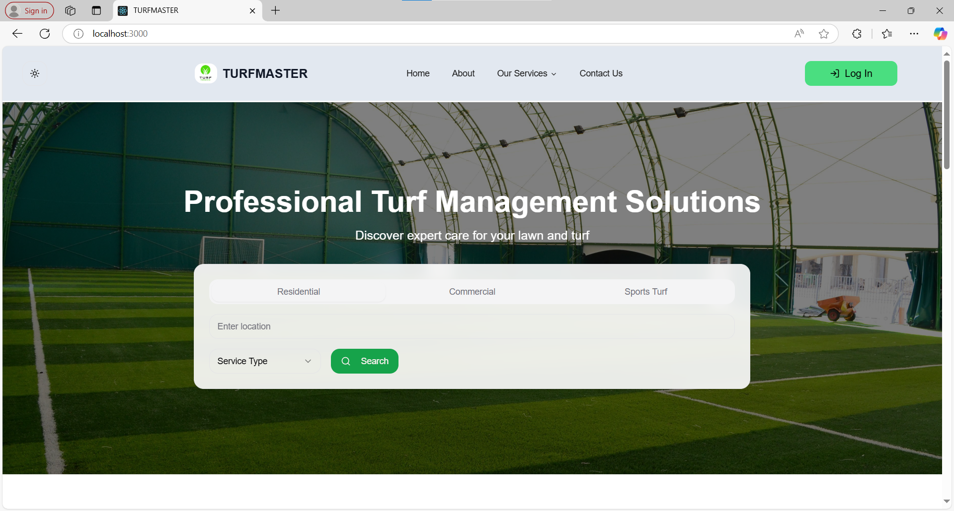

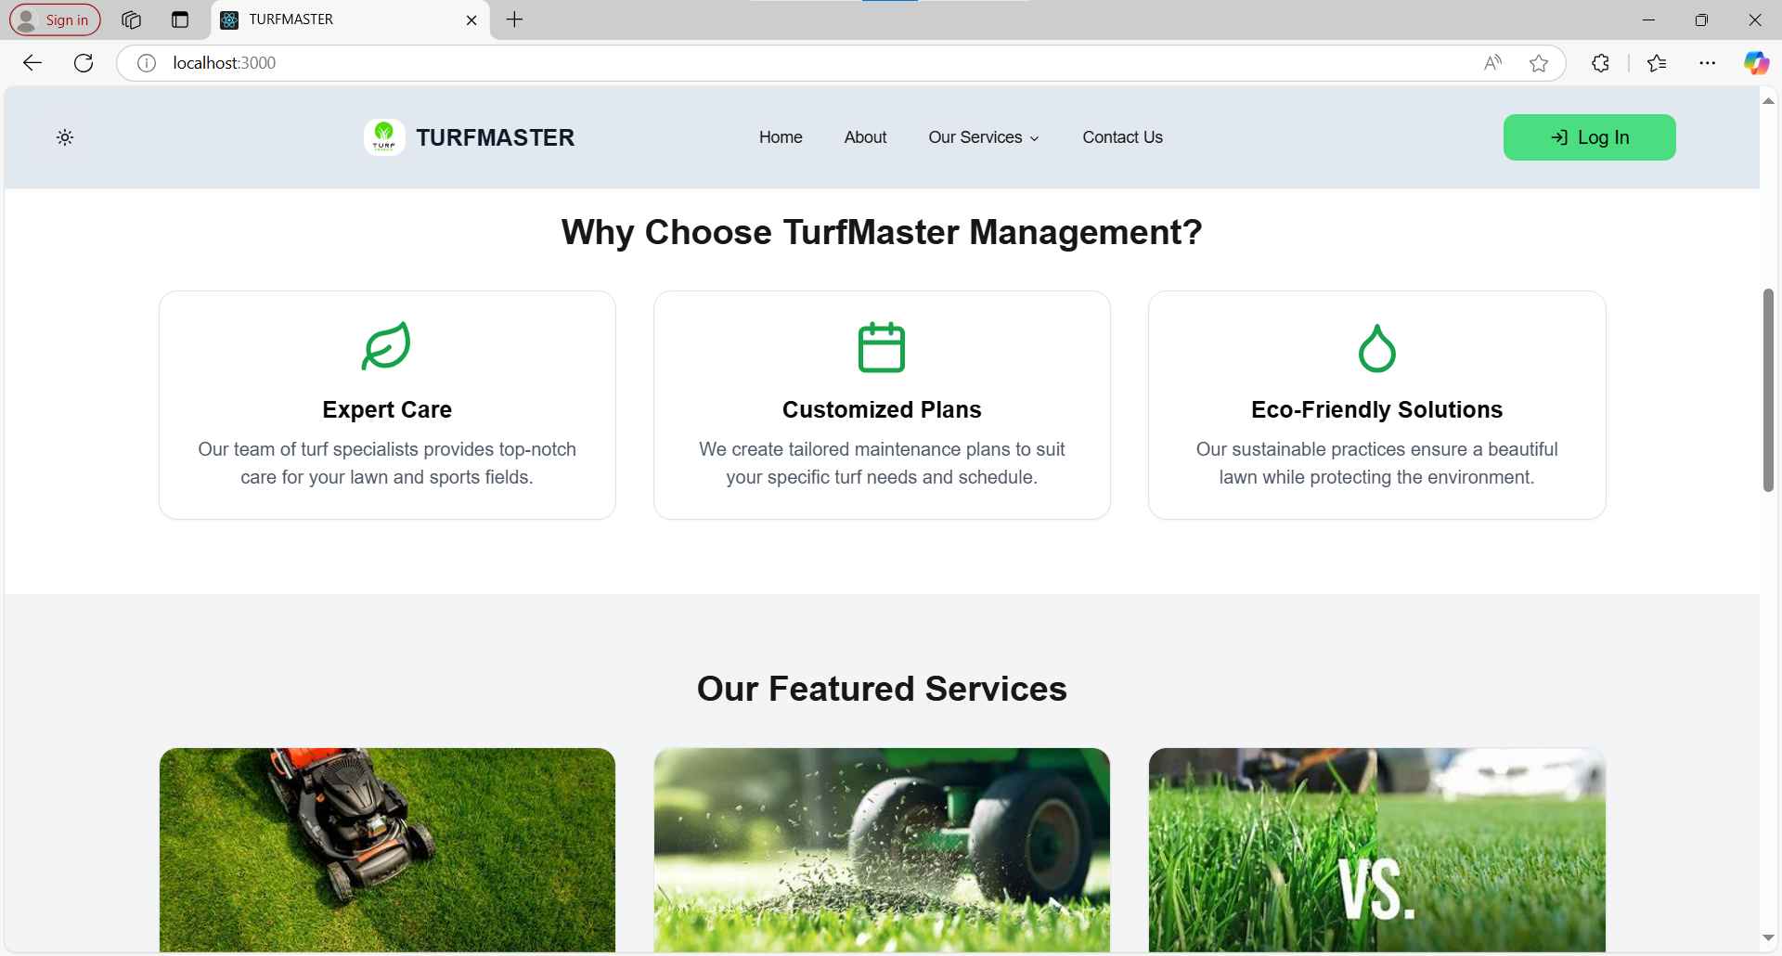

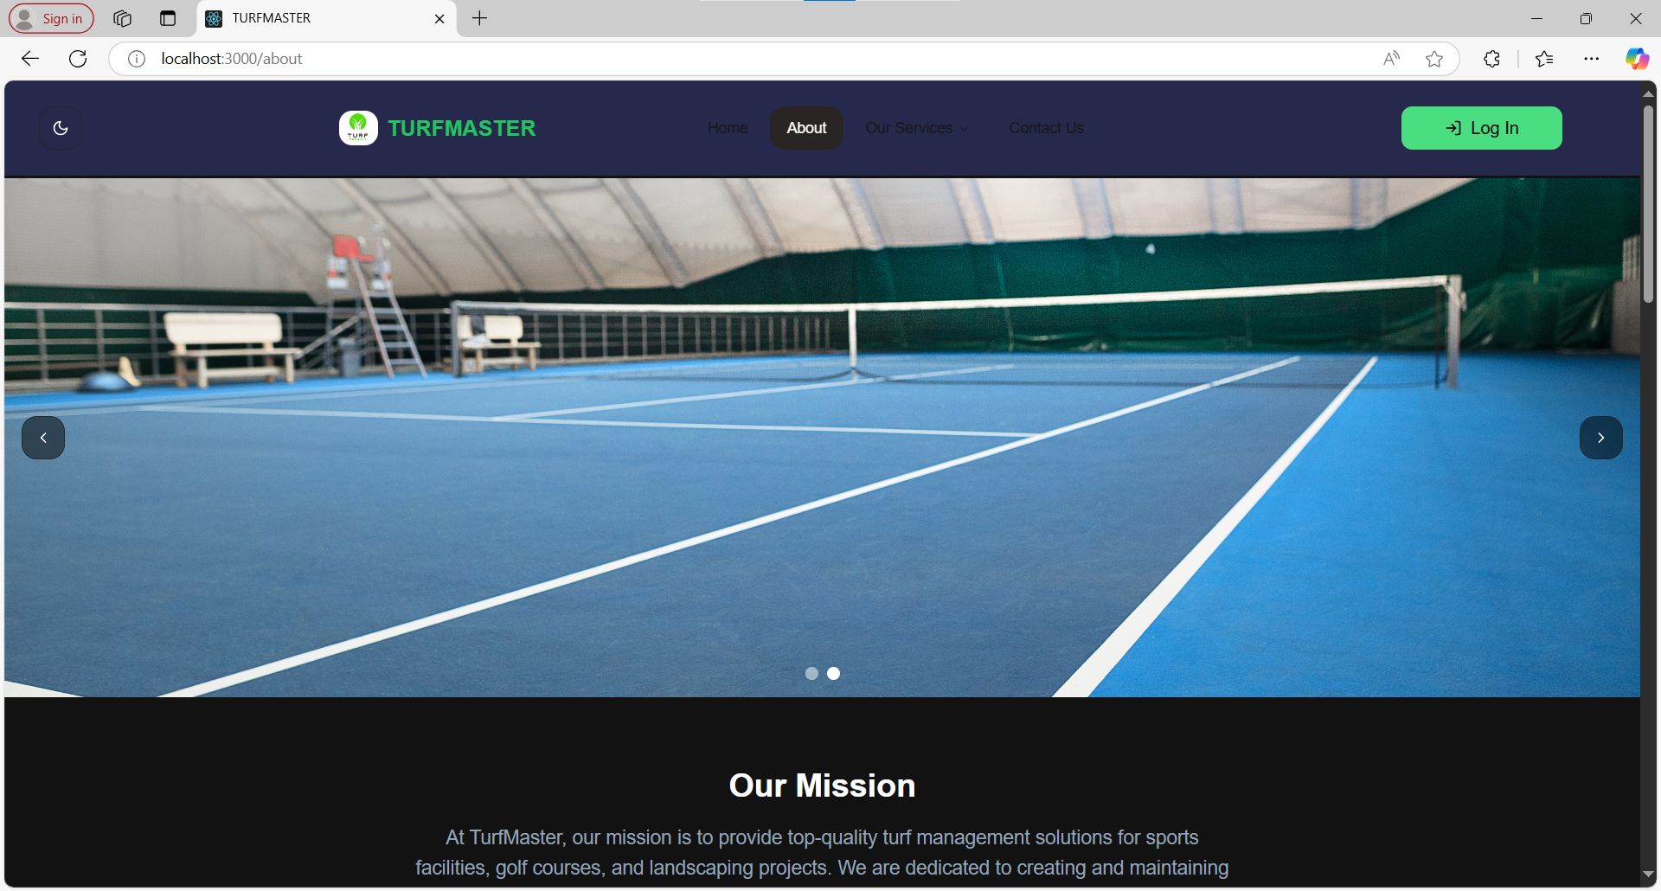

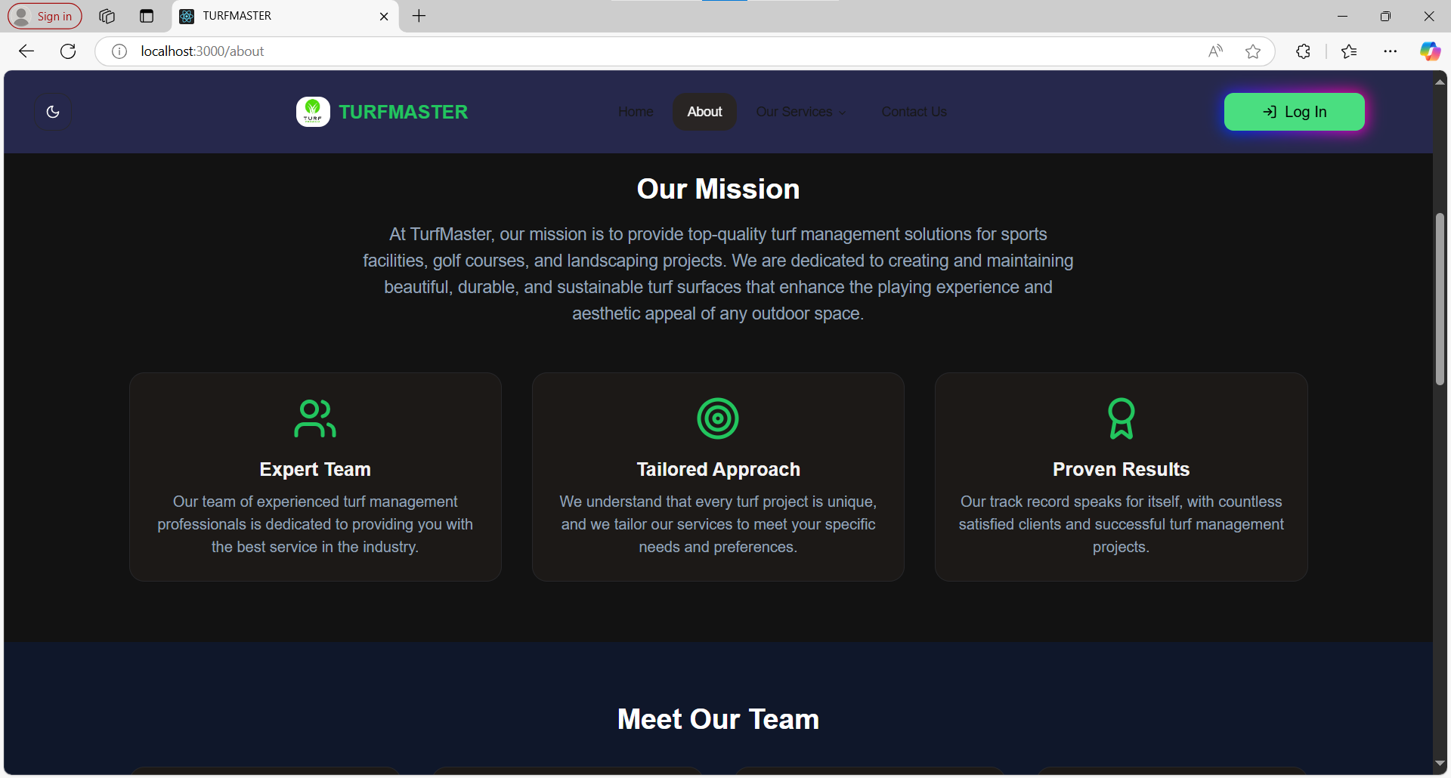

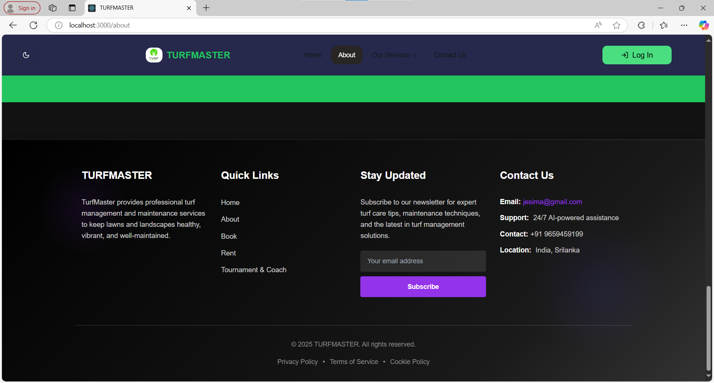

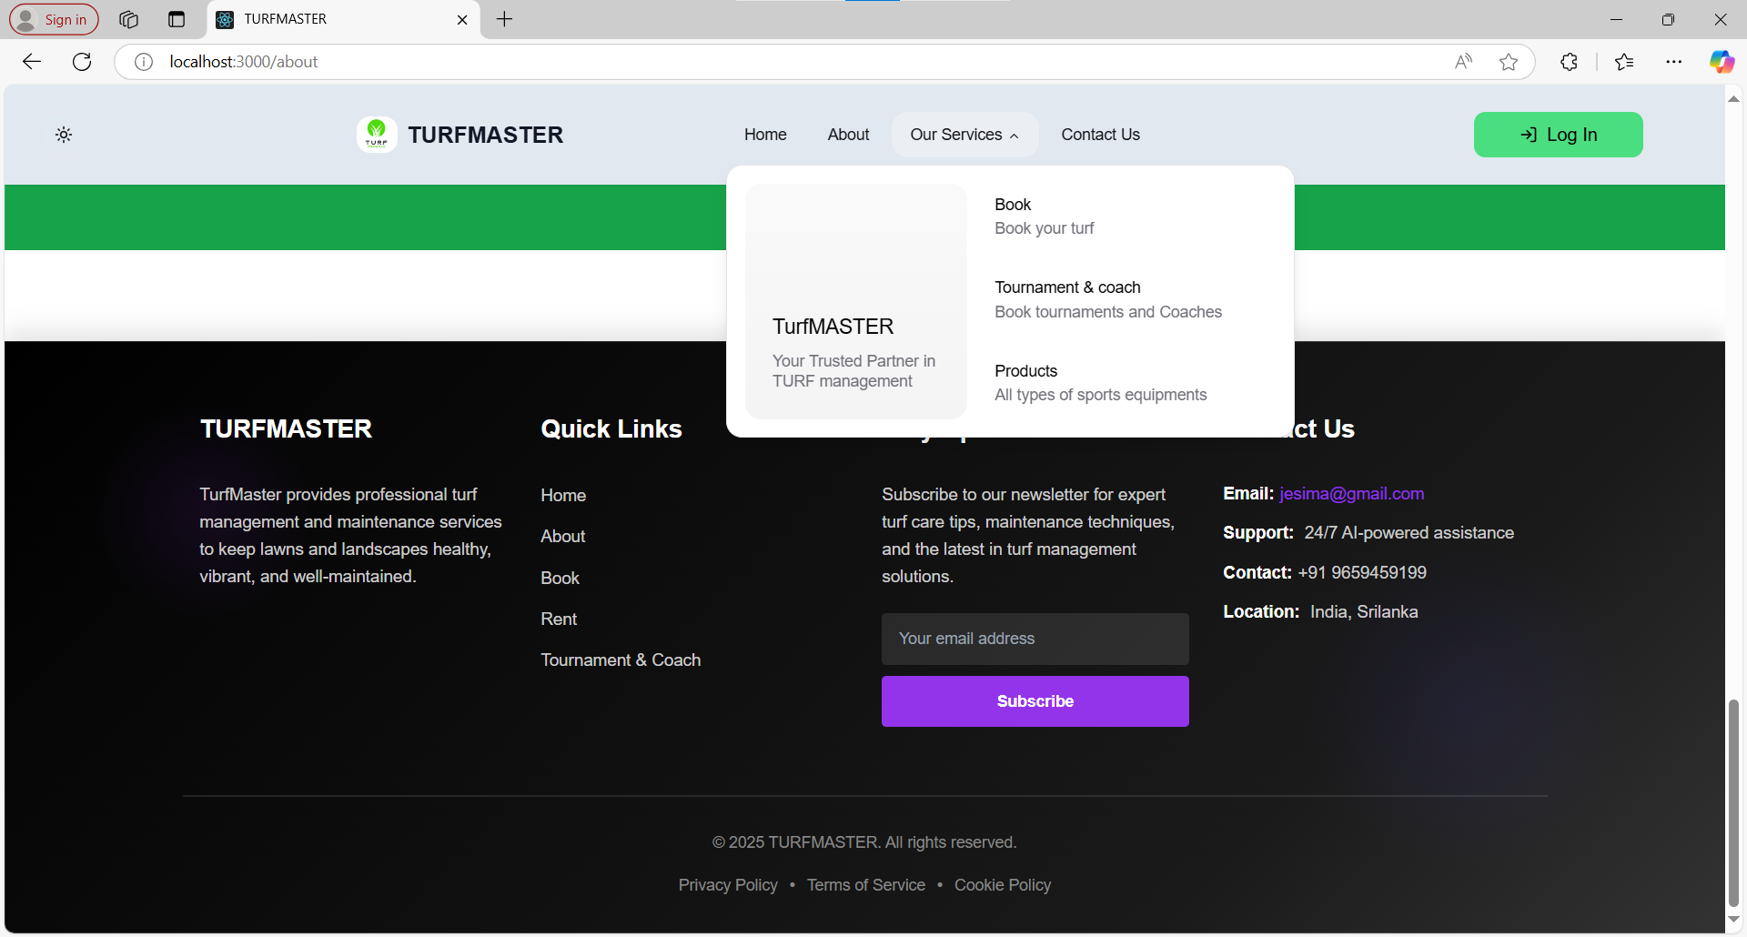

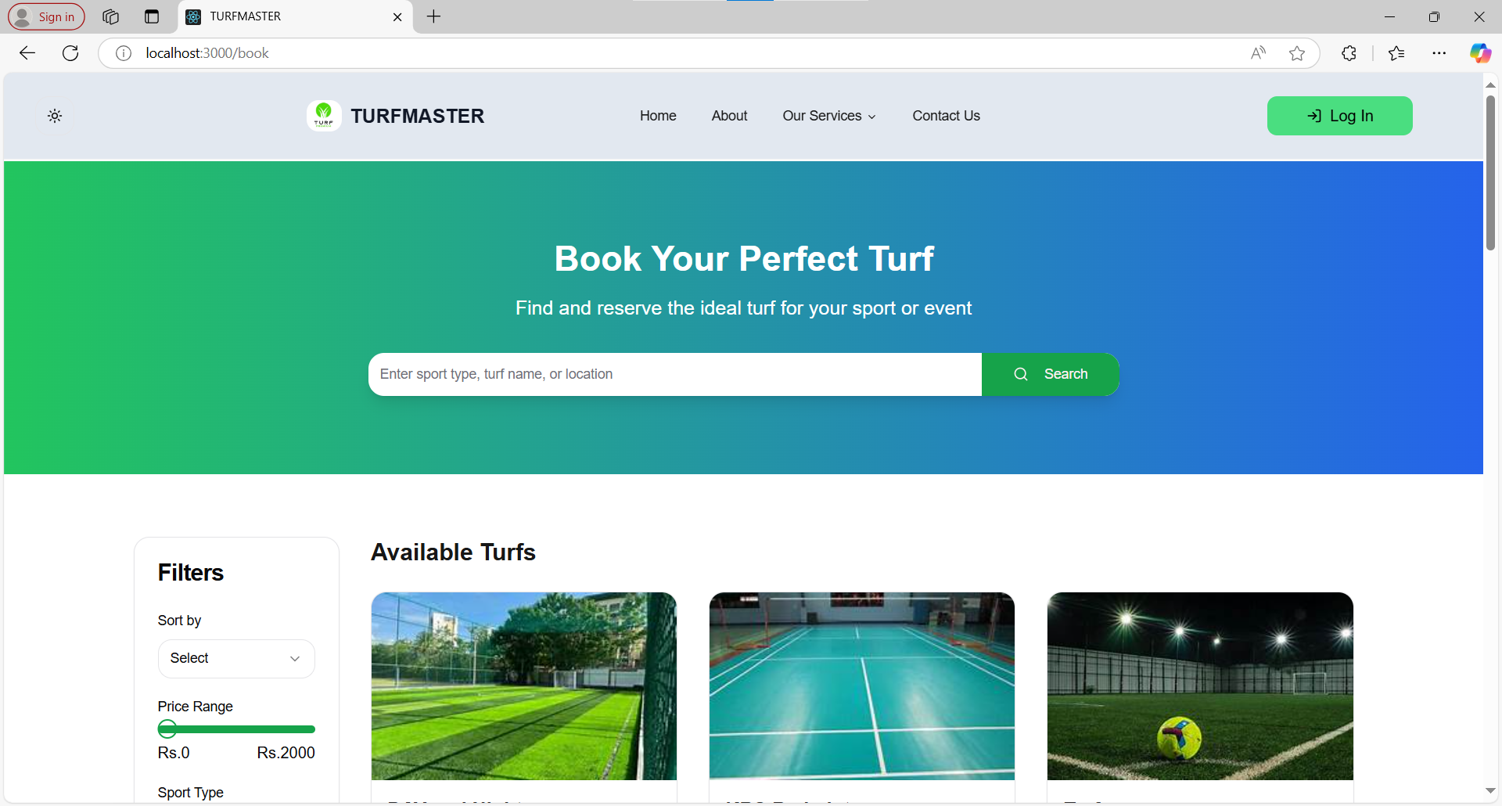

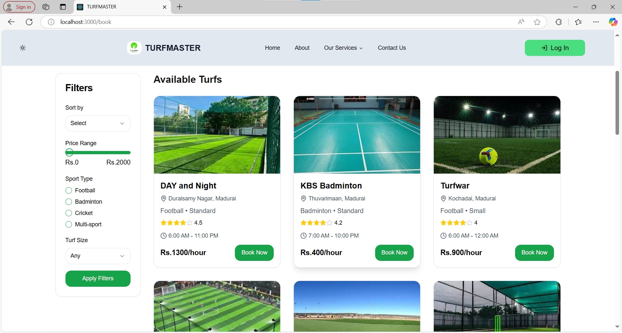

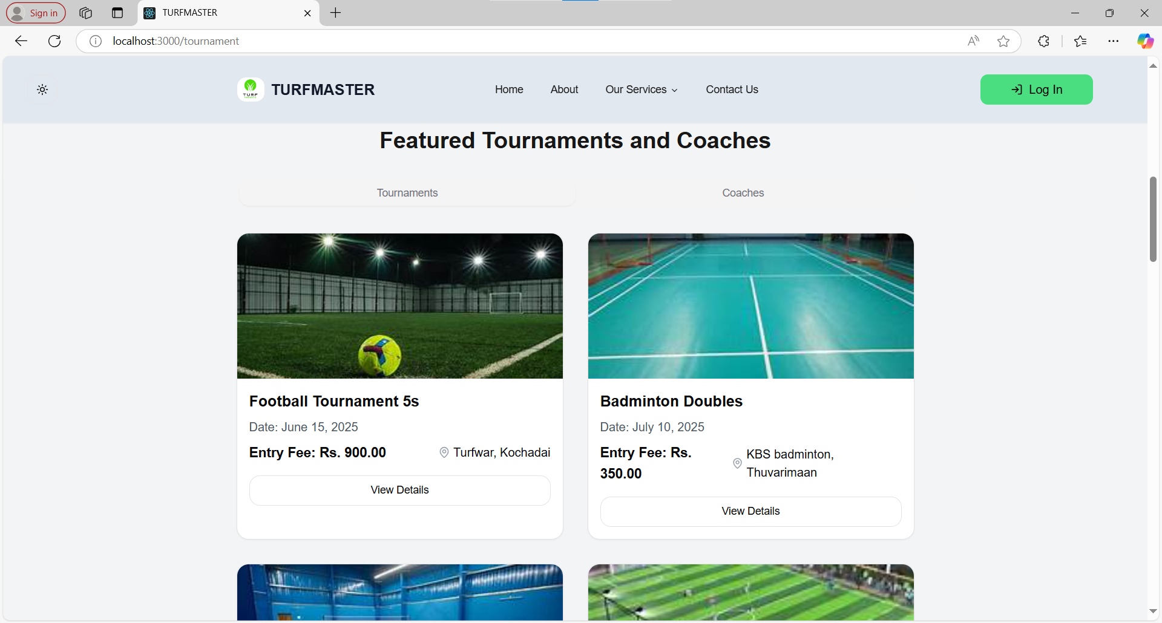

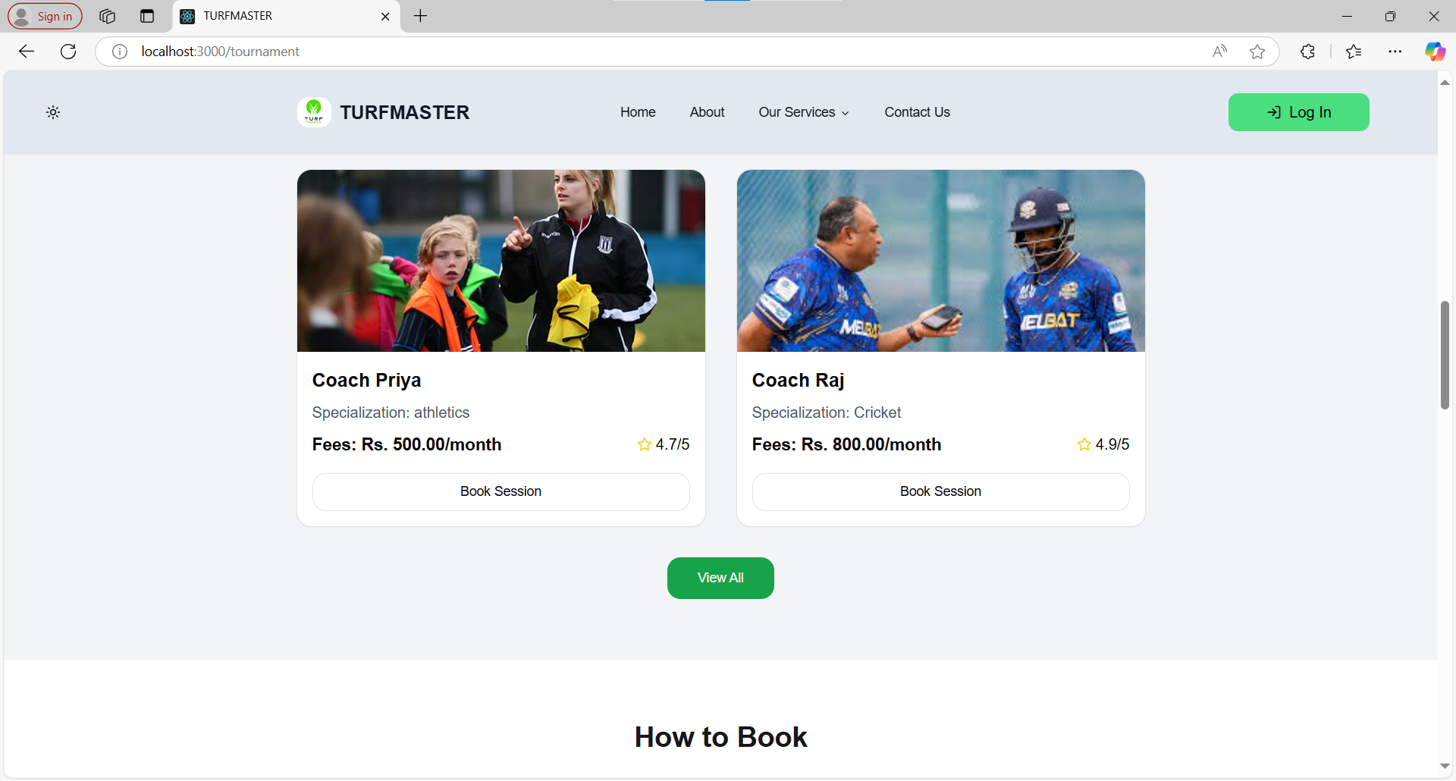

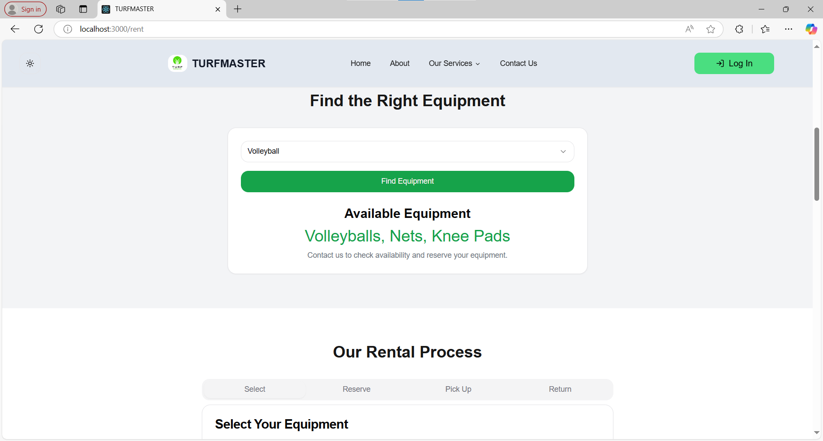

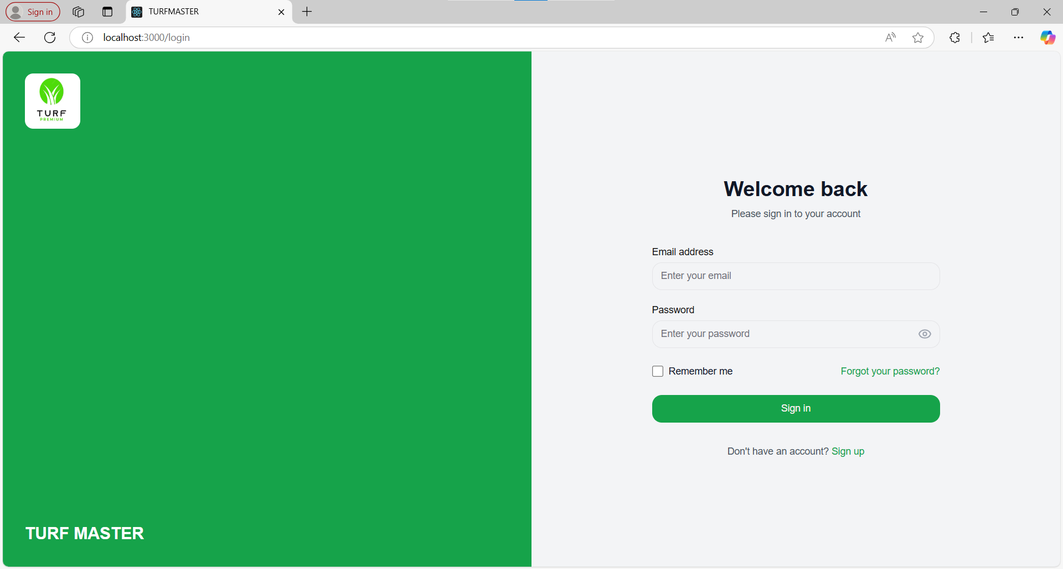

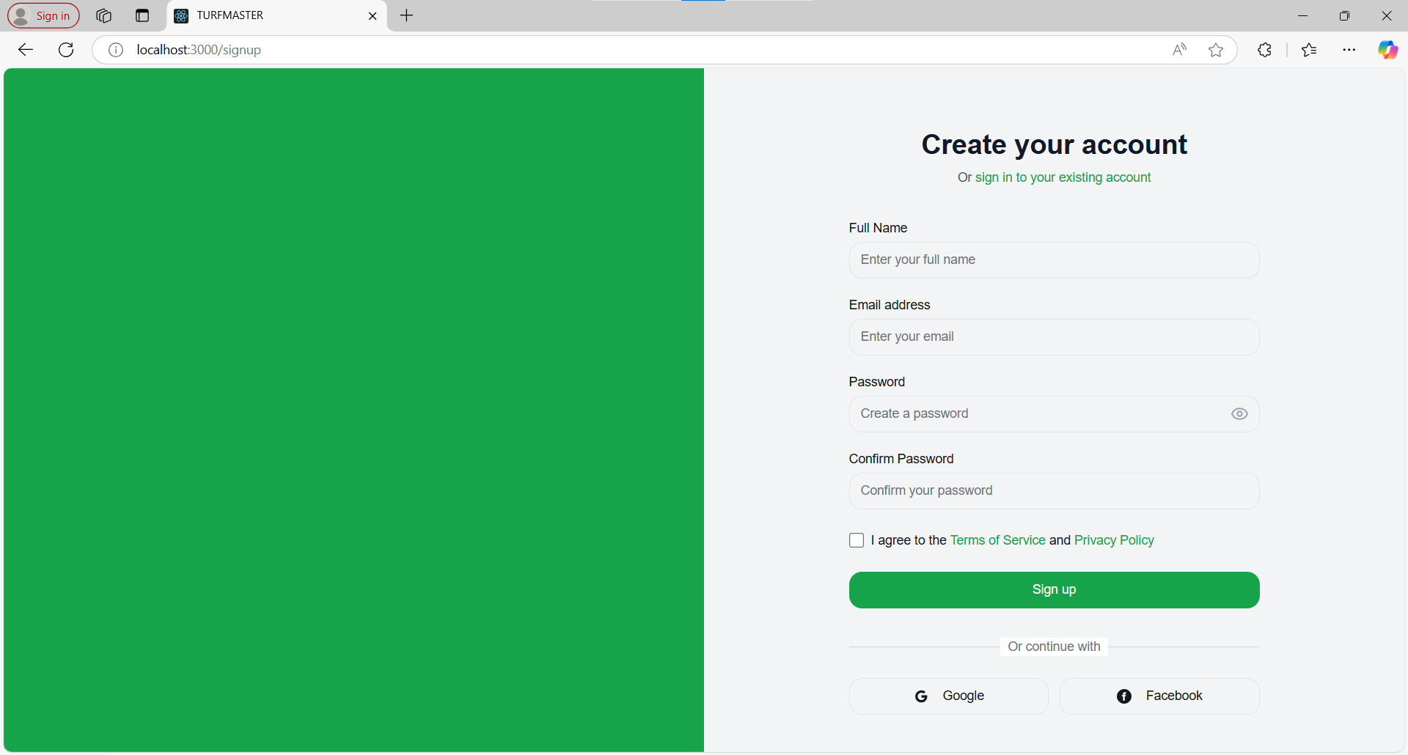

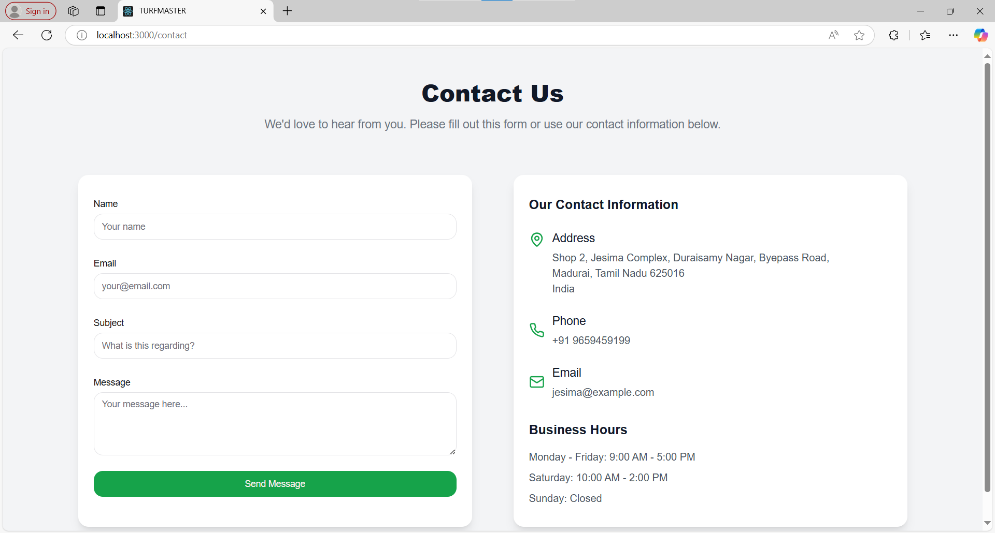

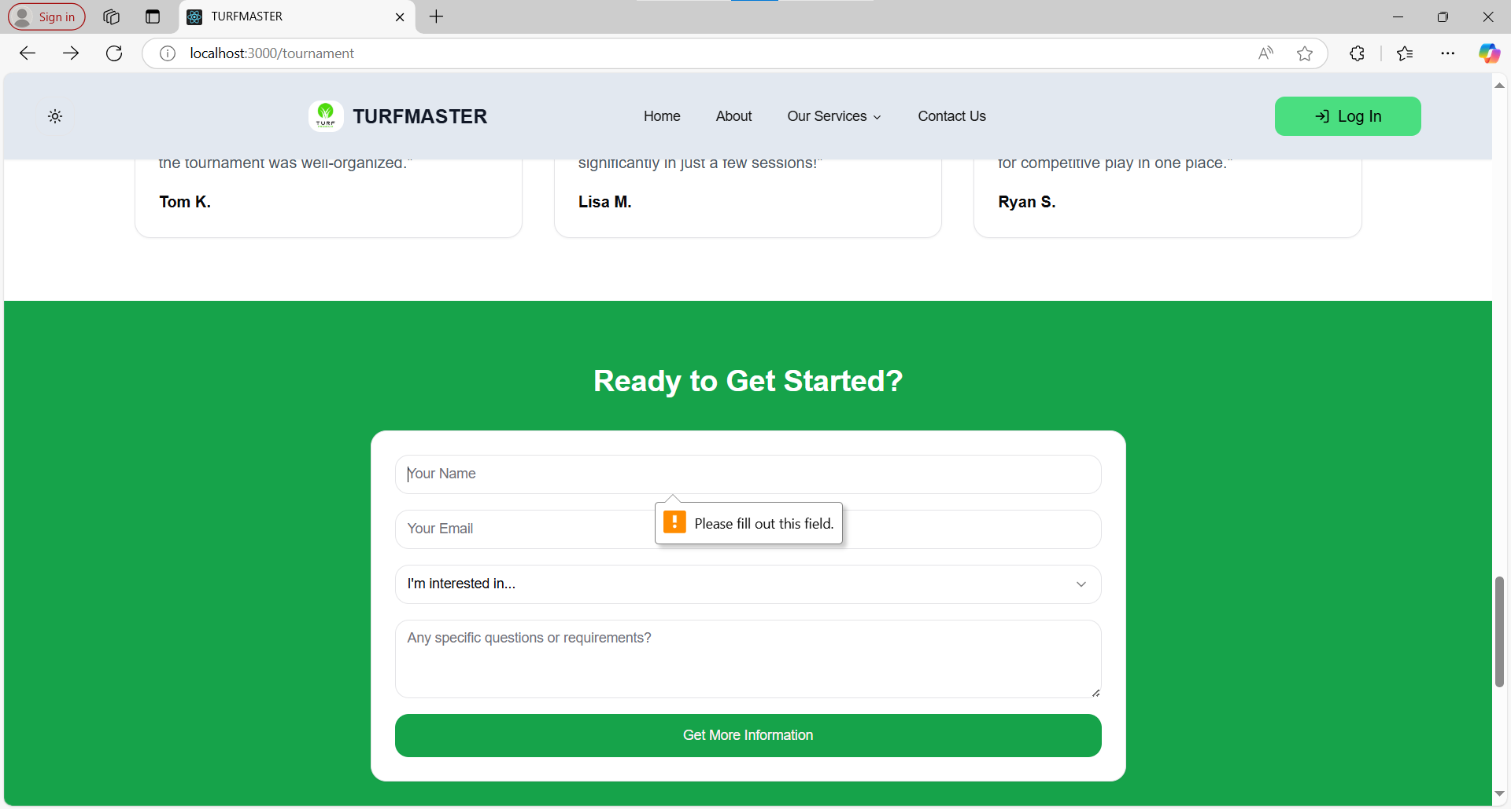

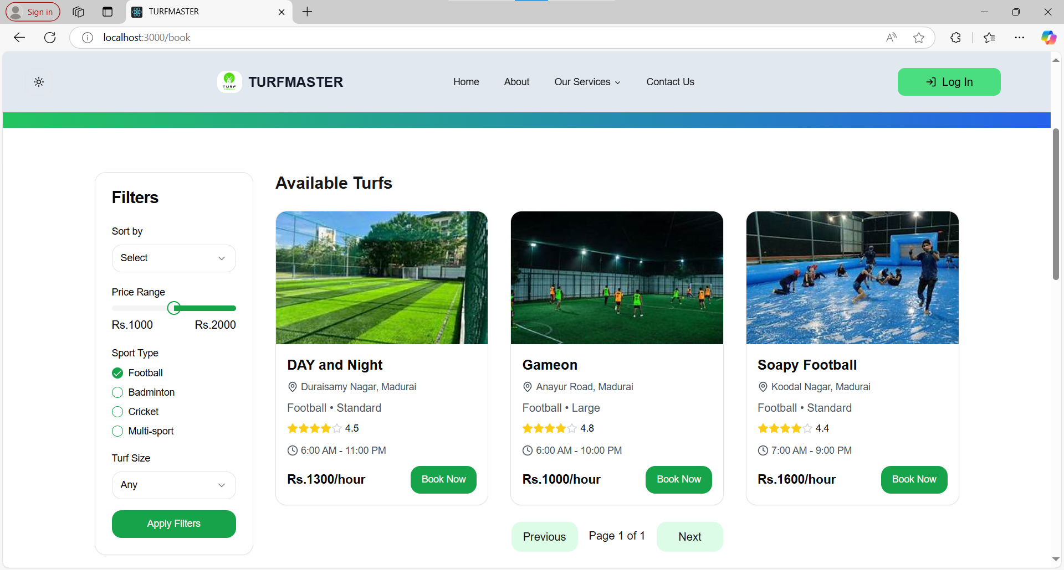

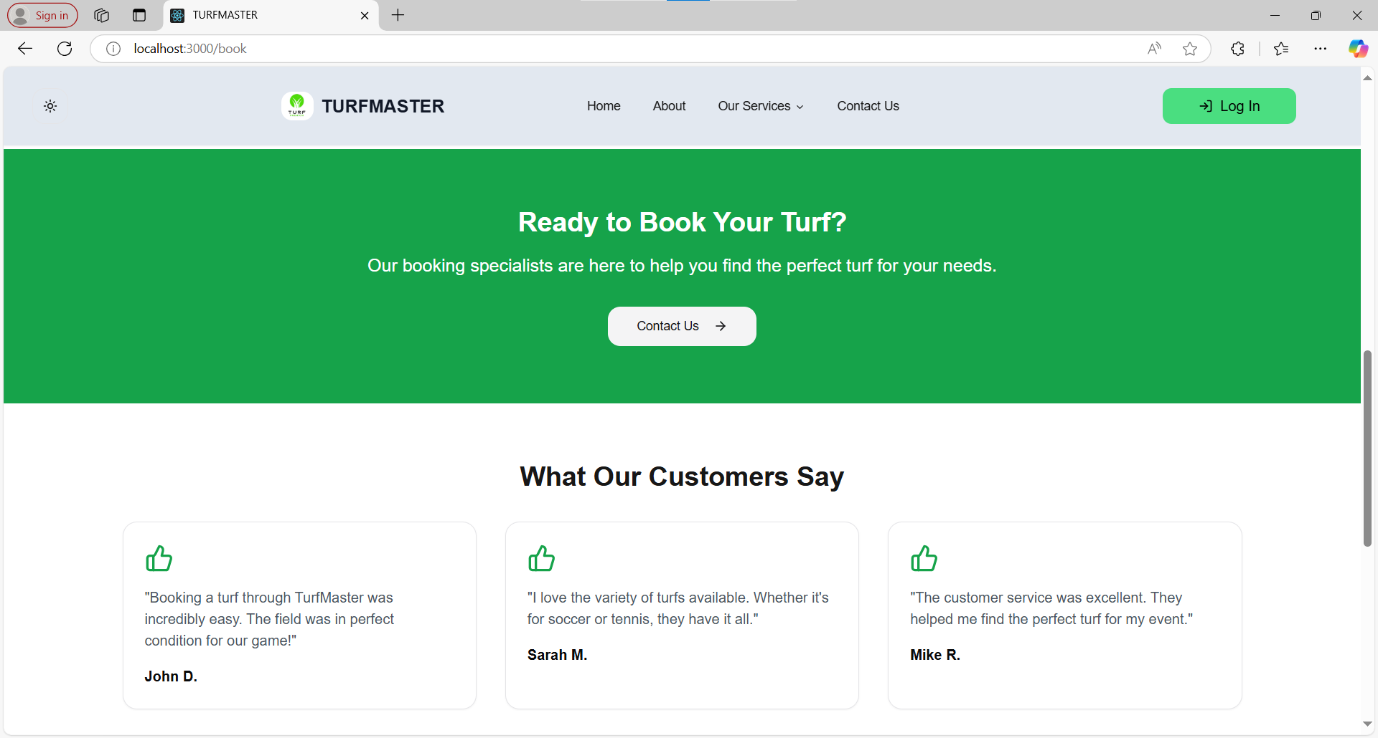

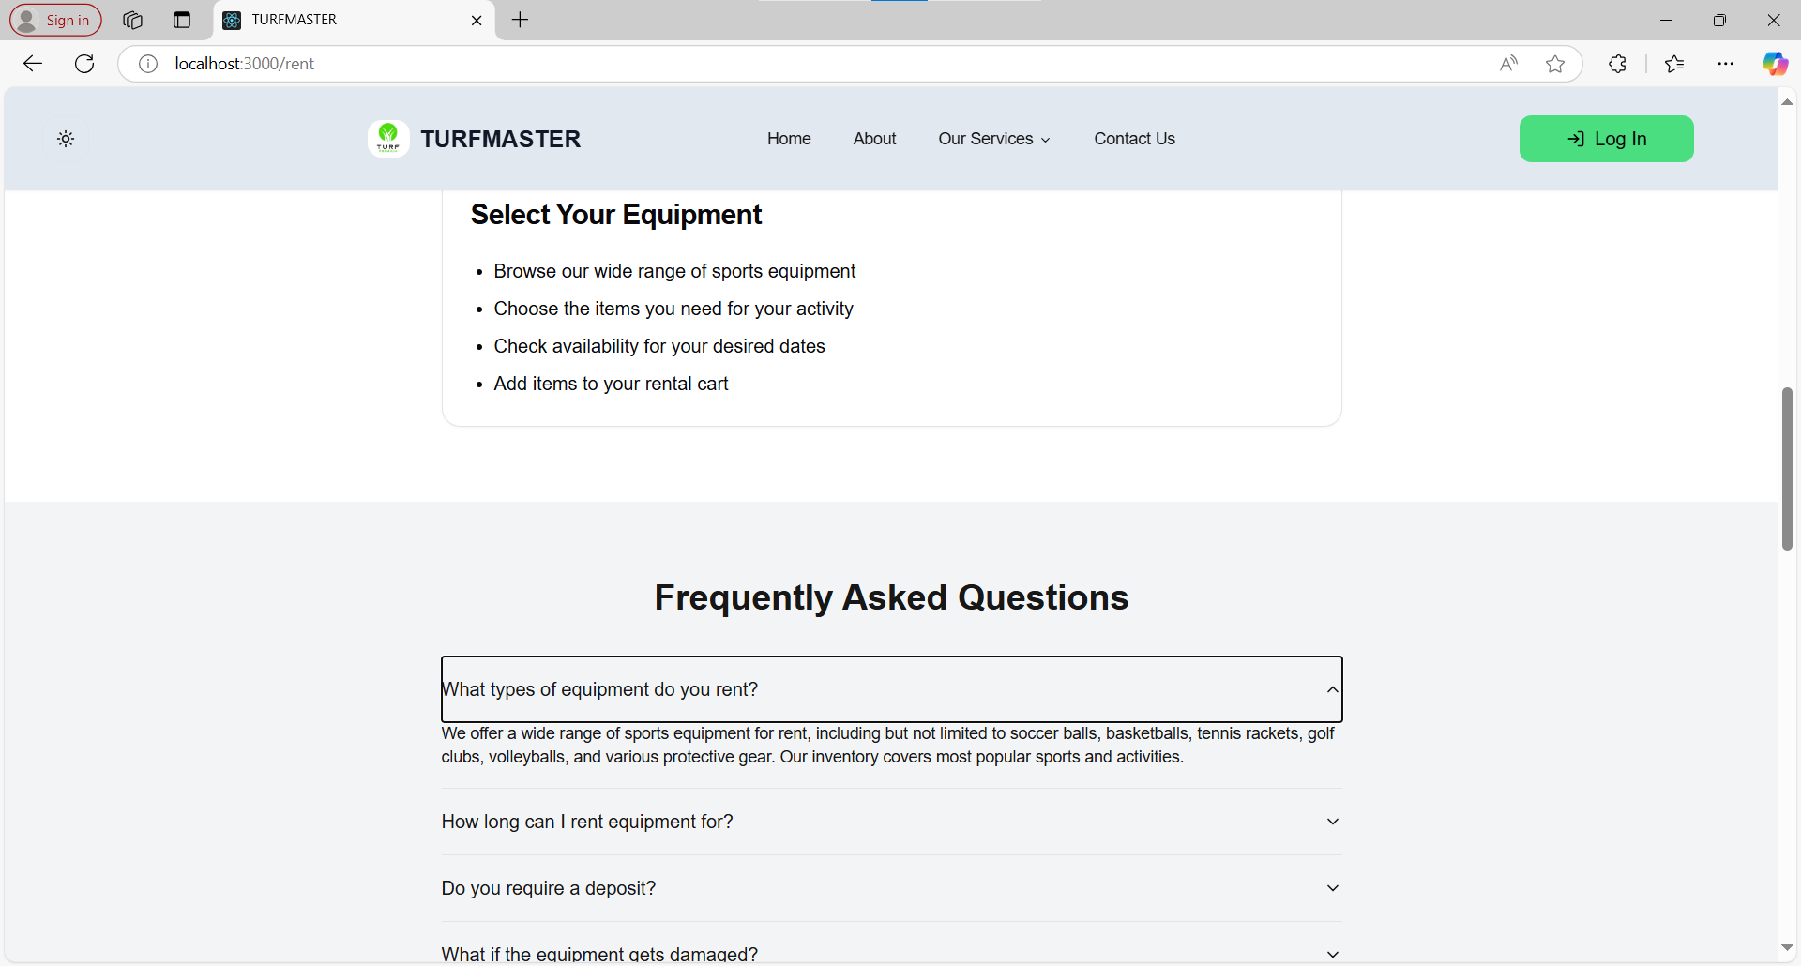

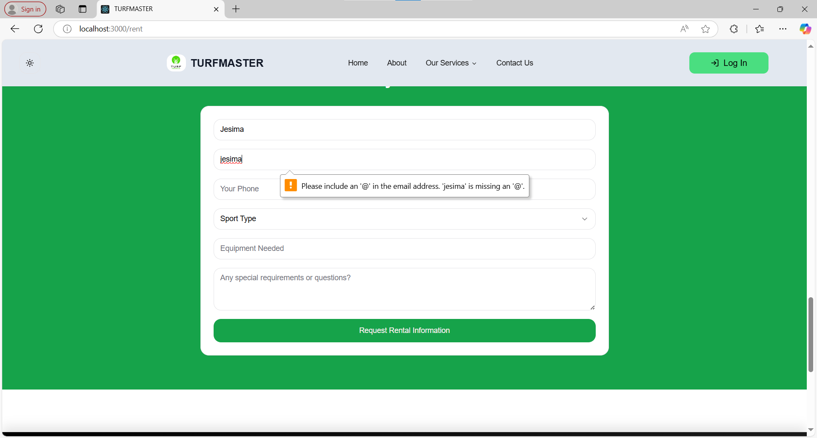

1. **SYSTEM TESTING FOR TURFMASTER**

The **TurfMaster** platform underwent rigorous testing to ensure optimal performance, reliability, and error-free operation. The following testing methodologies were applied:

**1. WHITE BOX TESTING**

White box testing was performed to evaluate the internal workings of the system. This method focused on:

* **Database Connectivity:** Ensuring proper ODBC connectivity for data retrieval from the database.
* **SQL Queries:** Testing CRUD operations (Create, Read, Update, Delete) for correct data manipulation.
* **Client-Side Validations:** Ensuring appropriate data types are entered (e.g., numeric values for fees, string values for names).
* **Server Stability:** The system was tested to verify database engine stability and uninterrupted data access.

*Example:* During tournament booking, queries were tested to ensure correct data insertion and retrieval from the backend.

**2. BLACK BOX TESTING**

This method was used to validate system functionality without focusing on internal code. It included:

* **Boundary Condition Testing:** Ensuring correct data behavior at minimum and maximum input values.
* **Conditional Testing:** Ensuring user-specific privileges are correctly applied.
* **Error Handling:** Ensuring proper error messages appear when invalid inputs are entered.

*Example:* If a user attempts to book a coach without sufficient balance, the system displays an appropriate error message.

**3. UNIT TESTING**

Individual modules were tested to verify their standalone performance. Key aspects tested included:

* **Login Module:** Ensuring correct authentication for valid and invalid credentials.
* **Search Module:** Confirming accurate tournament and coach search results.
* **Payment Module:** Verifying successful transactions and correct error messages for failed payments.

*Example:* The system was tested to ensure user profiles are saved correctly and display accurate details.

**4. TEST DATA**

The data used for testing was prepared in two stages:

* **Sampled Data:** Used for initial testing during development.
* **Actual Data:** Real data related to tournaments, coaches, and user profiles was employed for final testing.

*Example:* Test data included sample user accounts, tournament entries, and mock payments to ensure proper system behavior.

**5. VERIFICATION TESTING**

Verification was conducted throughout development to ensure intermediate steps were properly aligned with project objectives. Documents such as:

* Requirements specifications
* Database table designs
* ER diagrams
* Test cases

were consistently reviewed to ensure adherence to project goals.

**6. VALIDATION TESTING**

Validation ensured that the system met customer expectations. Three outcomes were tracked:

* The system functions as intended and meets requirements.
* Deviations or deficiencies were documented and corrected.
* Final testing confirmed the platform was working satisfactorily.

*Example:* Booking flows, search results, and coach communication features were all verified with real-world scenarios.

**7. INTEGRATION TESTING**

Integration testing ensured seamless communication between system modules. Key steps included:

* **Top-Down Integration:** Starting with high-level modules like the homepage and gradually integrating detailed features.
* **Bottom-Up Integration:** Testing individual features like search filters, booking processes, and payment integration.

*Example:* Testing confirmed that booking a coach triggers automated emails, profile updates, and calendar synchronization.

**8. USER ACCEPTANCE TESTING (UAT)**

The final step involved end-users evaluating the system to ensure it meets their needs. Key focus areas included:

* **Ease of Navigation:** Ensuring users could easily search, book, and manage accounts.
* **Performance Testing:** Verifying system speed, response time, and data accuracy.
* **Error Tolerance:** Ensuring the system handles incorrect entries gracefully.

A comprehensive test report was generated summarizing system performance, error rates, and stability.

**CONCLUSION**

The **TurfMaster Turf Management System** successfully delivered the expected results as proposed in the initial stages of development. This system was designed to streamline and enhance the management of turf facilities, bookings, and user interactions.

The system effectively enabled administrators to manage turf schedules efficiently, ensuring optimal usage of available slots. The intuitive booking module allowed users to reserve turfs seamlessly, minimizing conflicts and improving overall customer satisfaction.

Additionally, the system's robust design provided clear insights for staff to allocate resources efficiently. The integrated payment module ensured secure transactions, while automated notifications enhanced communication between users and administrators.

The **TurfMaster** system also offered detailed reporting features, providing valuable data on booking trends, turf maintenance schedules, and financial performance. This ensured better decision-making and improved overall management.

With its user-friendly interface, reliable functionality, and comprehensive features, the **TurfMaster Turf Management System** successfully met all project requirements and objectives, making it a valuable tool for managing turf facilities effectively.

**FUTURE ENHANCEMENTS**

Enhancements involve adding, modifying, or redeveloping the code to accommodate changing specifications and evolving user needs. Ensuring adaptability to meet these changes is vital for the long-term success of the **TurfMaster Turf Management System**.

1. **Advanced Booking System:**
   * Introduce dynamic pricing for peak and off-peak hours to improve revenue generation.
2. **Enhanced Reporting & Analytics:**
   * Develop an advanced Management Information System (MIS) that provides comprehensive insights into turf usage trends, customer preferences, and financial performance.
   * Add graphical dashboards with data visualizations to help administrators make informed decisions.
3. **User Profile Management:**
   * Introduce loyalty programs, user rewards, and membership tiers to encourage customer retention.
   * Enable users to track their booking history, performance statistics, and participation in leagues or tournaments.
4. **Automated Maintenance Scheduling:**
   * Implement an automated system for scheduling turf maintenance based on usage frequency to ensure optimal playing conditions.
5. **Secure Communication & Data Backup:**
   * Introduce end-to-end encryption for secure communication between administrators and users.
   * Implement file-level backup to ensure critical data is preserved, improving disaster recovery measures.
6. **Mobile Application Integration:**
   * Develop a dedicated mobile app for users to manage bookings, receive alerts, and access personalized content.
7. **Integration with Third-Party Services:**
   * Enable payment gateway integrations for seamless transactions.
   * Incorporate third-party sports management platforms to host events, leagues, and tournaments.

**10**. **BIBLIOGRAPHY**

1. **Next.js Documentation** - https://nextjs.org/docs
2. **PostgreSQL Documentation** - <https://www.postgresql.org/docs/>
3. **MongoDB Documentation** - <https://www.mongodb.com/docs/>
4. **React.js Documentation** - <https://react.dev/>
5. **Node.js Documentation** - https://nodejs.org/en/docs
6. **Tailwind CSS Documentation** - <https://tailwindcss.com/docs>
7. **Learning React: Modern Patterns for Developing React Apps** - *by Alex Banks & Eve Porcello*
8. **The Road to React: Your Journey to Master React.js** - *by Robin Wieruch*
9. **Learning JavaScript Design Patterns** - *by Addy Osmani*
10. **PostgreSQL: Up and Running** - *by Regina Obe & Leo Hsu*
11. **MongoDB: The Definitive Guide** - *by Shannon Bradshaw, Eoin Brazil, and Kristina Chodorow*
12. **Node.js Design Patterns: Master Best Practices to Build Modular and Scalable Server-Side Web Applications** - *by Mario Casciaro & Luciano Mammino*
13. **Full Stack Serverless: Modern Application Development with React, AWS, and GraphQL** - *by Nader Dabit*
14. **Prisma Documentation (For Database ORM)** - https://www.prisma.io/docs
15. **Mongoose Documentation (For MongoDB ORM)** - https://mongoosejs.com/docs/
16. **React Hook Form Documentation** - https://react-hook-form.com/get-started
17. **Zod Documentation (For Schema Validation)** - <https://zod.dev/>
18. **Shadcn/ui Documentation (For Modern UI Components)** - https://ui.shadcn.com/

**TABLE OF CONTENT**

|  |  |  |
| --- | --- | --- |
| **S.NO** | **PARTICULARS** | **PAGE NO.** |
| 1 | INTRODUCTION | 2 |
| 2 | SYSTEM ANALYSIS   * 1. EXISTING SYSTEM   2. PROPOSED SYSTEM | 3 |
| 3 | MODULE DESCRIPITION | 6 |
| 4 | SYSTEM SPECIFICATION   * 1. HARDWARE SPECIFICATION   2. SOFTWARE SPECIFICATION   3. ABOUT THE SOFTWARE | 8 |
| 5 | SYTEM DESIGN   * 1. DATA FLOW DIAGRAM   2. DATABASE STRUCTURE   3. CODING | 23 |
| 6 | SYSTEM IMPLEMENTATION | 42 |
| 7 | SYSTEM TESTING | 55 |
| 8 | CONCLUSION | 60 |
| 9 | FUTURE ENHANCEMENT | 61 |
| 10 | BIBLIOGRAPHY | 62 |